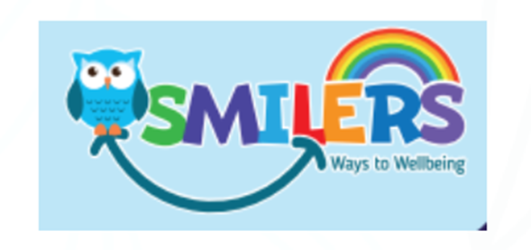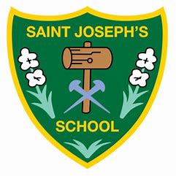
SMILERS
SMILERS is a whole school approach to wellbeing.
It is a way of helping children understand that they can make choices to help them feel better mentally and help them stay emotionally strong and well.
We will use the SMILERS formula to help us develop healthy habits for life and to look after our own wellbeing
This month’s focus is: S for Support

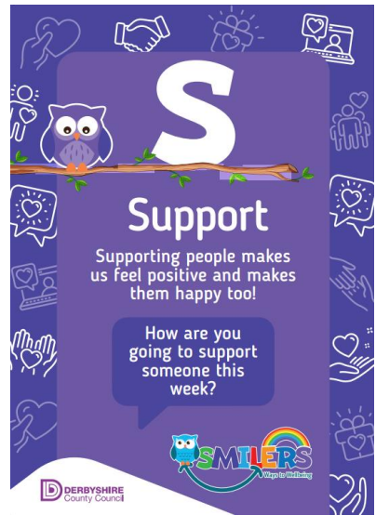

SUPPORT

We are all different and unique and have own our path to Wellbeing. However, as individuals we can help ourselves by helping others. Staying connected to other people and offering support where we can or even showing we have thought of someone else often gives other people and ourselves a boost. Being kind to others can make us feel positive and makes them happy too. Imagine if you were feeling sad and someone asked if they could help or you were lonely and someone offered a friendly ear. Making connections and offering support to others is something we can all do. In a world where we can be anything, we should be kind and offer support where we can to others.
SUPPORT
There are many ways your child can support others. Here are some suggestions:
• Volunteering
• Sort out your old toys or clothes and make donations to charity
• Ask someone to play
• Arrange a play date
• Make your friend a card
• Speak to someone new in your class
• Play with someone in a different year group
SMILERS Challenge:
This month try to offer support to someone else. Play with someone new, ask how someone is or give someone a compliment. These things help them and you.

