Child Friendly Mental Health and Emotional Wellbeing Policy



Contents
- About this policy
- What does mental health and wellbeing mean?
- Who can we talk to?
- How does our school teach us about mental health and wellbeing?
- How do we know when we are not OK?
- What can we do to look after our own mental health?
- What can we do if we are finding our feelings overwhelming?
- How can we help our friends and other children in our school?
- What can we do if we need further support?

- About this Policy

At St Joseph’s Catholic Primary School, we promise to help you understand your emotions and feelings better so you can be happy and confident in school. This policy has been written by the staff on the Mental Health and Wellbeing team and the Mental Health Ambassadors to show you how you can help your own emotional wellbeing and ensure you feel comfortable sharing any worries or concerns. This policy also signposts you to where you can access further support if you need to.

It is important to remember that we all go through life’s ‘ups and downs’ and at times this can be overwhelming. It is OK to ask for help and have a little more emotional support when we need it.



- What does it mean?
Important fact – the body and mind are connected

We all have Physical and Mental Health.

If we are struggling with our physical health this can affect how we feel = our mental health.
If we are struggling with our mental health this can also affect our bodies = our physical health.
By looking after our Mental Health and Physical Health we can improve how we feel = wellbeing.
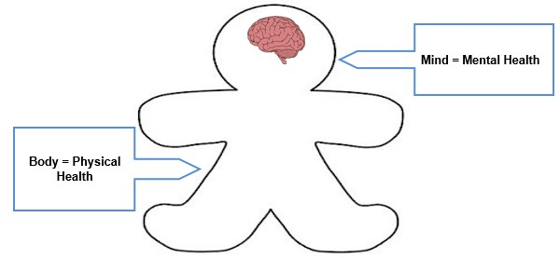

Mental wellbeing is about feeling good. It is feeling that life is going well and feeling able to get on with everyday things.
It is being able to deal with life’s ups and downs, being able to learn and enjoy friendships, being able to meet challenges and develop talents and capabilities.

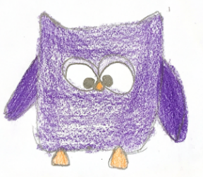
Everyday Feelings
We all have lots of feelings that come and go every day.
For example, feeling excited about a present, nervous about going back to school or frustrated because you missed a penalty.
Everyday feelings can feel very strong and intense at times. They can feel uncomfortable sometimes but this is normal for everyone.



Big Feelings
Big feelings can change how we think, feel and behave, how we see the world and how we get on with other people. They can affect our mental health and can be really serious for some people. They can make someone feel lonely or overwhelmed by the feeling.

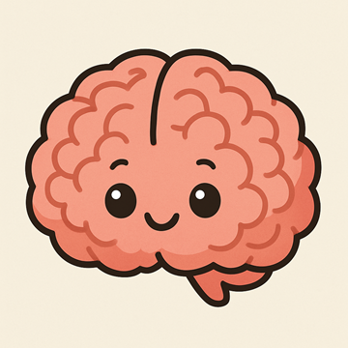
Big feelings might:
- Affect our sleep
- Make us worry a lot.
- Affect our confidence.
- Affect how we speak or behave around others.
- Make us want to be alone.
- Make it difficult to concentrate.
- Make us lose interest in things we normally enjoy.

- Who can we talk to?
Remember if your feelings are getting too big to cope with on your own and you feel you want to change things…
…talking to someone you trust might really help.

This could be:
- Parents or carers
- Teachers
- Friends
- A trusted adult
- Other family members
- Older brothers or sisters
- Mrs Webster – ELSA/MHFA
- Miss Todd - ELSA

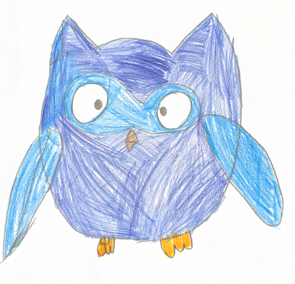
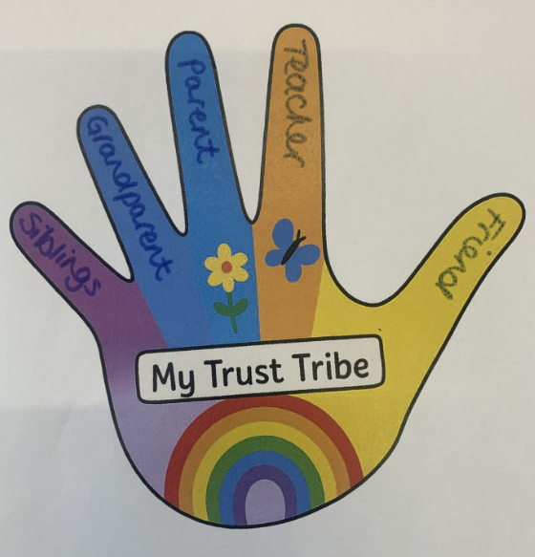
Think about the people you might talk to for advice or support if you were feeling worried or stressed.
These people make up your trust tribe.

- How does our school teach us about mental health and wellbeing?

At St Joseph’s Catholic Primary School, we teach RSHE lessons. Topics include exploring our emotions and being healthy which covers both physical and mental health. We learn about the importance of being healthy and staying fit through our PE lessons.

We also have assemblies throughout the year, which focus on emotional wellbeing. Some of these are led by our Mental Health Ambassadors.

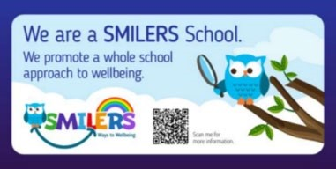

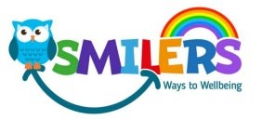
We are a SMILERS School

Have you ever heard of the 5 ways to wellbeing?

The Five Ways to Wellbeing are some simple little things we can choose to do every day to help with our wellbeing. This can make us feel happier and cope better with daily life and the challenges we all face.


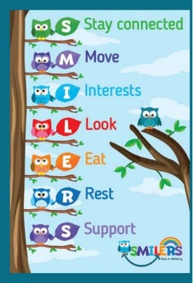
SMILERS have used the Five Ways to Wellbeing and adapted it, so it is easier to remember. Two other areas have been added, which are also important to maintain good wellbeing and these seven ways to wellbeing are called SMILERS.
St Joseph’s Catholic Primary School launched SMILERS in June 2023. It was launched by the Mental Health Ambassadors who meet regularly and plan wellbeing activities throughout the year to keep SMILERS alive.
The Mental Health Ambassadors lead and champion mental health and wellbeing in school. They run activities in school teaching their peers how to stay mentally health.
In school, we also have ELSA and Drawing and Talking. Every class has a SMILERS/calm area and a worry box.

- How do we know when we are not OK?
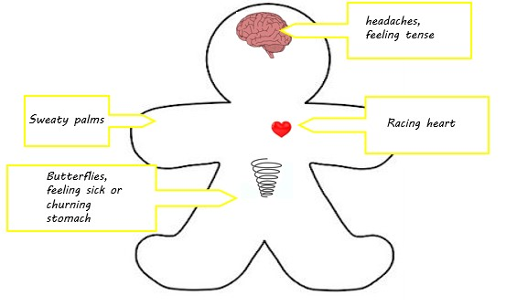

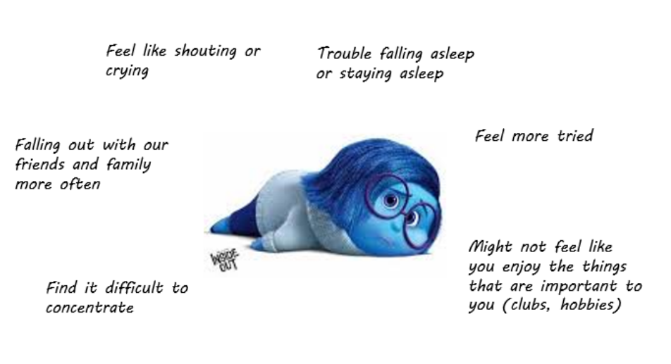

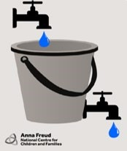
Lots of different things can make us feel stressed. Too much stress can cause our stress bucket to overflow.

What could fill a stress bucket?

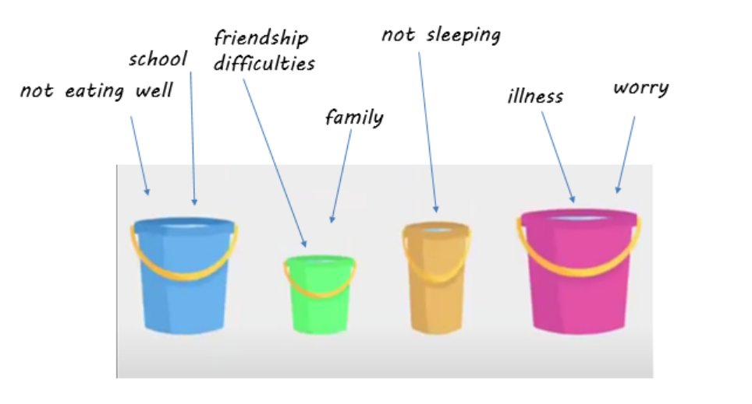

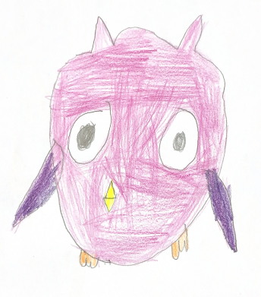

- What can we do to look after our own mental health?

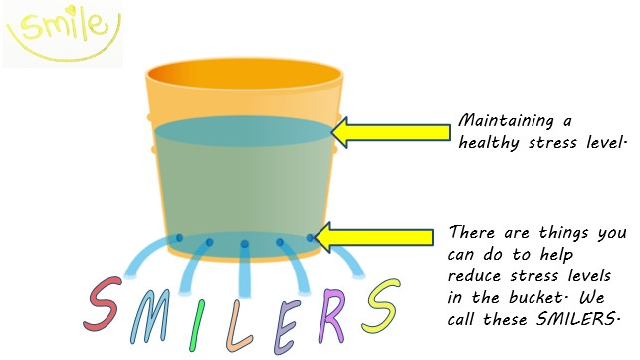
Ways to manage our stress bucket.

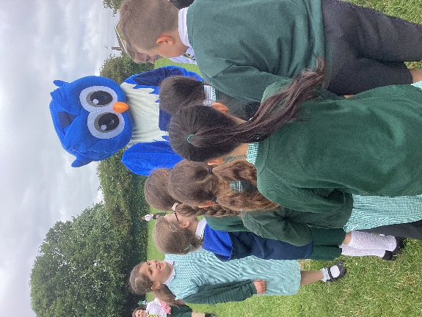

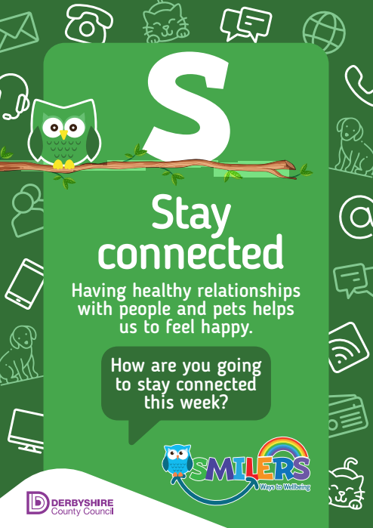

To stay connected with others you could:
- Spend time with friends or family
- Talk to and play with different children at play time
- Include others in your games
- Join a club
- Write a letter or send a card

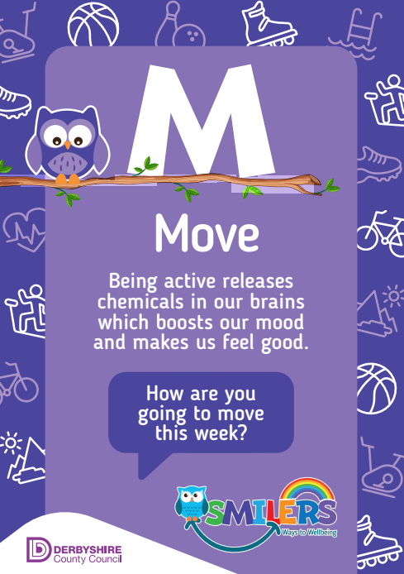

To make sure we move we:
- Can go for a walk in our local park
- Can go to a play centre
- Can join an after-school sports club
- Play games at lunch time
- Have P.E lessons each week

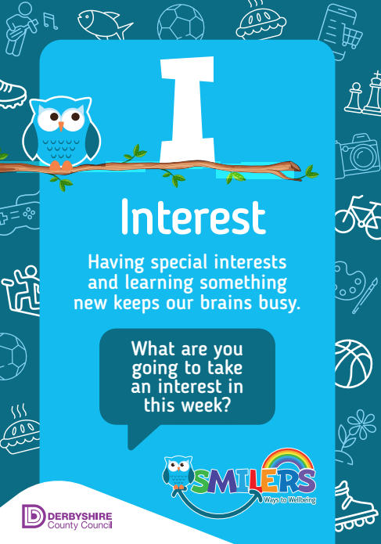
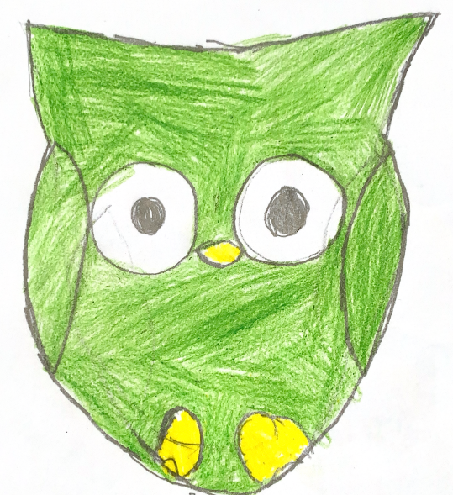

To take an interest, you could:
- Read about something you enjoy
- Join in with activities in the community
- Try different things
- Learn something new

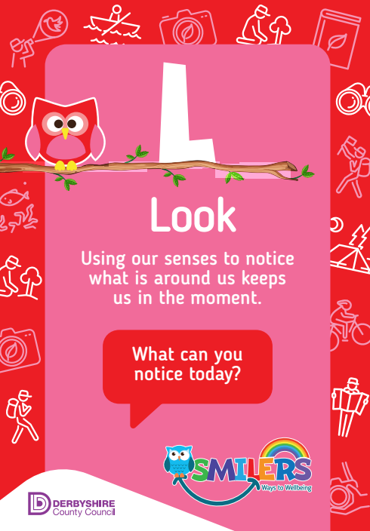

To look and take notice, you could:
- Play a game of ‘I spy’
- Go on a walk with your family
- Look for patterns in clouds
- Go on a scavenger hunt
- Play hide and seek

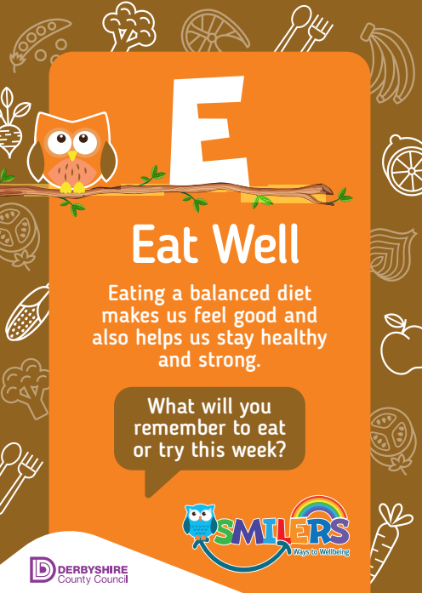
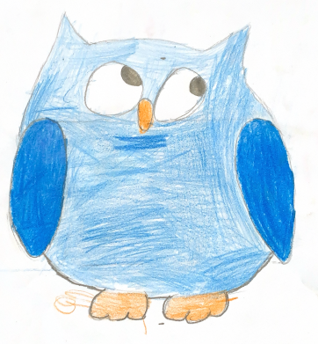

To help you to eat well, you can:
- Eat 5 pieces of fruit or vegetables a day
- Swap foods for healthier alternatives
- Make sure you drink enough water

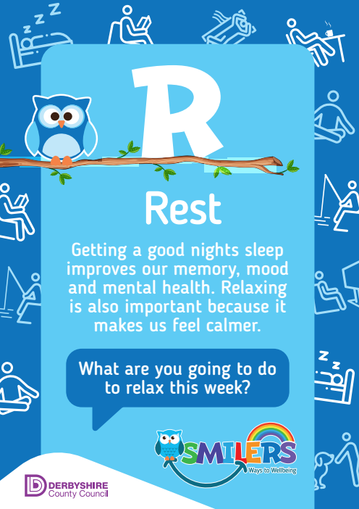

To help you to rest, you can
- Go to bed at a sensible time
- Have a bath before bed
- Avoid looking at screens before going to sleep
- Read a book before going to sleep
- Have a hot drink

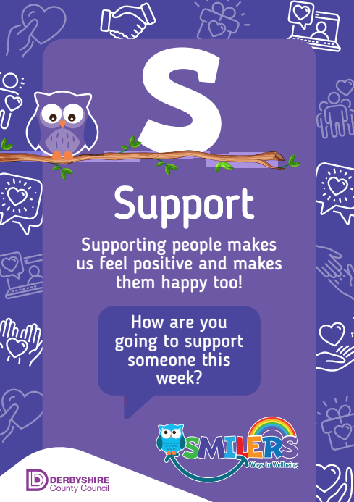
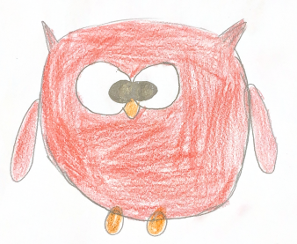
To support others, you could
- Offer support or comfort to someone who is upset
- Encourage others
- Include other people in games
- Say thank you
- Smile
.

- What can we do if we are finding our feelings overwhelming?

Our worries and feelings can sometimes feel really big and they weigh us down. Or we might think our worries are really silly. This can make us feel like someone wouldn’t understand them. But if we keep our worries to ourselves or ignore them they can get bigger and heavier.
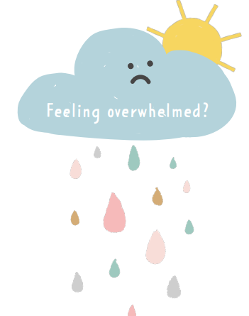






Allow yourself to feel the big feeling. It is Ok to feel this way.
Recognise you are experiencing a big feeling.
Focus on your next steps. Think about what you are going to do. The feeling won’t last for ever.
Interrupt your big feeling by doing something new, distracting yourself or talking to someone about it.

- How can we help our friends and other children in our school?

Having good friends makes you happy and being a good friend to others makes them happy too. We can help others by being a good friend. Good friends:

- make you feel good.
- say and do things that make you feel good, giving compliments and congratulations and being happy for you.
- support each other
- will support you if you are feeling down. If you need help, a good friend will try to help you out.
- don’t always have everything in common.
- understand that everyone is different, and have different hobbies and interests. Even if you’re not into the exact same things, a good friend will encourage you rather than making you feel bad for liking a different band, activity, TV show or animal!
- understand that sometimes you do your own thing and enjoy doing the things you have in common together.
- listen
- allow you to talk and don’t interrupt you. They’re interested in what you have to say.
- are trustworthy

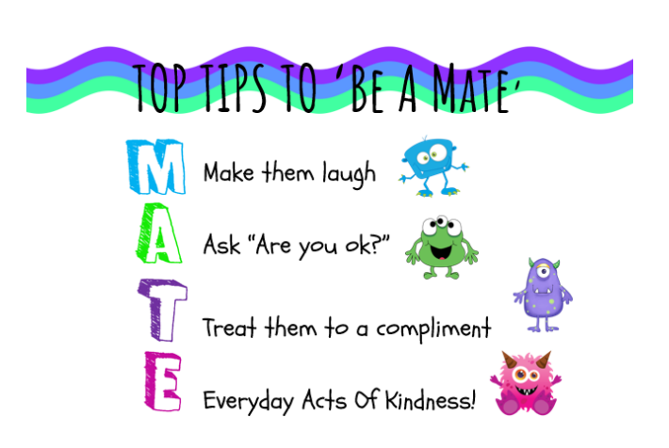

- What can we do if we need further support?

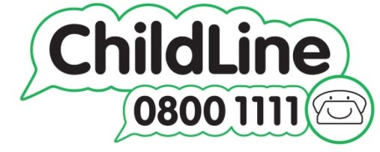
ChildLine is a free, private and confidential service where you can talk about anything.
https://www.childline.org.uk/about/about-childline/


YOUNGMINDS provide young people with tools to look after their mental health. Their website is full of advice and information on what to do if you're
struggling with how you feel. They give young people the space and confidence to get their voices heard and change the world they live in. Together, their vision is to create a world where no young person feels alone with their mental health.
https://www.youngminds.org.uk/

 NottAlone is a dedicated website providing information and support for young people’s mental health across Nottingham City and Nottinghamshire County. If you are aged under 25, are a parent or carer, or a professional who works with and supports young people, you can find information, advice and where to go to get help in Nottinghamshire.
https://www.nottalone.org.uk

