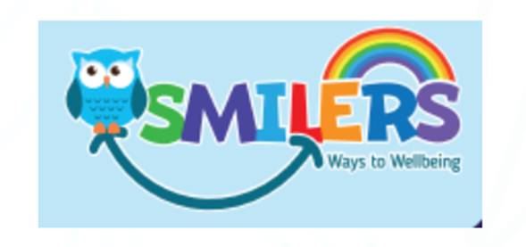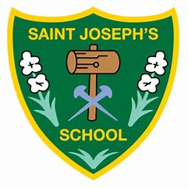
SMILERS
SMILERS is a whole school approach to wellbeing.
It is a way of helping children understand that they can make choices to help them feel better mentally and help them stay emotionally strong and well.
We use the SMILERS formula to help us develop healthy habits for life and to look after our own wellbeing.
This month’s focus is: I……for Interest
INTERESTS
We are all different and unique and have different
interests and things, we enjoy. Having special interests and activities, as well as learning something new, outside of school helps us keep busy and active. This gives us an opportunity to succeed and helps build our confidence.
We have spoken to a range of children in school and have found out some of the INTERESTS children have outside of our school. These include:
- Football
- Tennis
- Swimming
- Cycling
- Rainbows
- Beavers
- Brownies
- Cubs
- Dancing
- Gymnastics
- Jujitsu
- Karate

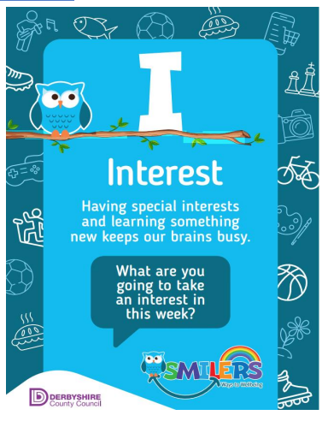

SMILERS Challenge:
Over the next few weeks, we challenge your child to try a new interest, hobby or pass time. Send a picture into school of them completing this activity.
INTERESTS
Many children also have interests beyond clubs. Some children like history, some like experimenting, and others like doing crafts and making things or reading. Hobbies are really good to keep children’s minds busy and help them to be active.
Maybe your child would like to take up a new hobby.
Why not try:
drawing, gardening, painting, model making, Lego, music, sewing, baking, reading, researching, looking after pets, the great outdoors and many more.

