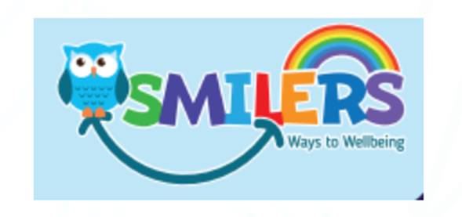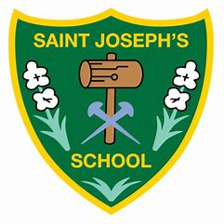
SMILERS
SMILERS is a whole school approach to wellbeing.
It is a way of helping children understand that they can make choices to help them feel better mentally and help them stay emotionally strong and well.
We will use the SMILERS formula to help us develop healthy habits for life and to look after our own wellbeing.
This month’s focus is: M……for Move
How to get Moving:
There are the obvious ways to move, like walking, running, skipping hopping etc. and there are the common physical activities like football, swimming, tennis etc.
However just playing inside and out is good for children and can help them to get moving (especially outdoors).

Moving doesn’t need to cost money, just a walk about your local environment will help. But play barns, trampoline parks and local parks can all help get kids active.
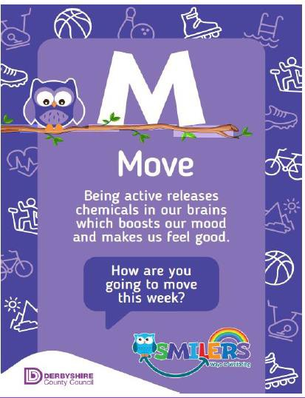
SMILERS Challenge:
All children need to be doing at least 30 minutes of activity/movement on school days (as the rest would be done in school) and 1 hour at weekends and in the holidays.
Have a go at some of the above ideas to get Moving. We look forward to hearing how you get on.

