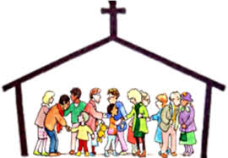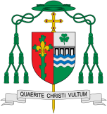

**This Topic learning outcomes are to know and understand:**

• About the different books used at home and in school – Explore

•The books used in Church on Sunday by the parish family – Reveal

Good News of Jesus – Reveal

**Scripture** Luke 1:1-3

Many people have done their best to write a report of the things that have taken place among us. They wrote what we have been told by those who saw these things from the beginning and who proclaimed the message.

Books

The scriptures are the treasured Word of God for the Jewish and Christian communities.

REFLECTION

Lord, you fulfilled the hope of Simeon who did not die until he had been privileged to welcome the Messiah.

In Sacramental Celebrations we meet the Risen Christ. May he continue to give us life.

Amen.

Missionary Disciples

**OUR BIG QUESTION**

What is good news?

**KEY VOCABULARY**

Scripture lectern Gospel Bible New Testament Old Testament genre thurible missalministers readers choir priest

**Key Questions**

How many kinds of books do we use and why? What is special about the Bible and why it is important to us?

What were special times for Jesus?

Why do we need books?

The lectionary which is used at Mass contains the scriptures used by the community throughout the year. In the sacred books, the Father who is in heaven comes lovingly to meet his children and talk with them.