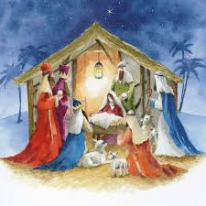****

Jesus was not a passing visitor, but One who comes to dwell among us, the Word made flesh. The joyful expectation of Advent, is an encouragement to take steps to recognise the coming of God into the world today, and to believe that in the future this same God will come again in glory. God has fulfilled the promise he made to Abraham and his descendants. He acted far beyond all expectation – he has sent his own ‘beloved Son’.

**This Topic learning outcomes are to know and understand:**

* The demands and joys of visitors

*Advent: waiting for the coming of Jesus

Visitors

For Christians, this topic emphasises the coming of God, in the person of Jesus, 2,000 years ago at Bethlehem.

**Scripture** John 1:9-12 The true light that enlightens everyone was coming into the world. He was in the world, and the world was made through him, yet the world knew him not. He came to his own home, and his own people received him not. But to all who received him, who believed in his name, he gave power to become children of God.

REFLECTION

Today a Saviour is born! In the stillness of the night God enters human history through the birth of his only Son. He is our peace and hope. In him we praise God for his

goodness to us in giving us so great a gift.

Amen.

Encounter

**OUR BIG QUESTION**

What is good news?

**KEY VOCABULARY**

Joys visitors Isaiah Messiah Advent Annunciation

The Visitation Magnificat

**Key Questions**

How are visitors welcomed?

What are the joys and demands of visitors?

Are visitors always welcome?