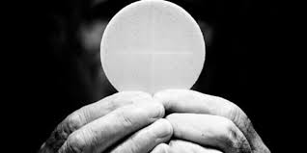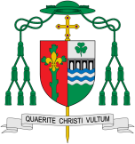

Unity

Communion means breaking and sharing the consecrated Bread which Catholics believe is the Body of Christ. To celebrate Eucharist means community.

**This Topic learning outcomes are to know and understand:**

• What nourishes and what spoils friendship and unity – Explore

• The Eucharist challenges and enables the Christian family to live and grow in communion every day – Reveal

**Scripture** Romans 12:4-5

For as in one body we have many members, and not all members have the same function, so we, who are many, are one body in Christ, and individually we are members one of another.

REFLECTION

Lord Jesus Christ, in you we know the love of God. When we gather in your name, we experience the marvel of your loving presence which challenges us to live for one another. Help us to follow your example so that we may never become complacent. Help us to listen to your constant call to us to continue the work you began, you who lived and died for us.

Grant this through your Spirit of Love.

Amen.

Why are we happiest when we are united?

**Key Questions**

What helps friendships to grow? What makes unity between people? What undermines friendship and unity?

**KEY VOCABULARY**

Eucharist, communion, community, unity, friendship, nourish

Encounter

**OUR BIG QUESTION**

What is good news?

For Christians, communion has a significant meaning. To receive communion means being in union with Jesus Christ and with one another. It means breaking and sharing the consecrated Bread which Catholics believe is the Body of Christ. To celebrate Eucharist means community. It challenges believers to ask, ‘Can I share this Eucharist if I do nothing to help my brother or sister who is hungry?’ ‘Can I partake of this communion if I refuse to forgive a wrong?