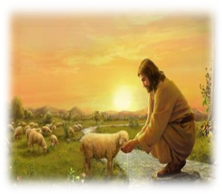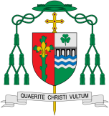

**KEY VOCABULARY**

unconditional, forgiveness, mercy, prodigal, parable, reconciliation

Loving

God is the loving parent of the human family and Jesus was born and lived in a human family. God’s love is unconditional and eternal.

REFLECTION

Father, creator of all, you ‘ordered the earth’ to bring forth life and crowned its goodness by creating family life. Teach us the beauty of human love, show us the value of family life and help us to live in peace with everyone.

Amen.

**Scripture**

Isaiah 54: 10

The mountains and hills may crumble, but my love for you will never end; I will keep for ever my promise of peace.

Discipleship

**OUR BIG QUESTION**

What is good news?

**Key Questions**

Does love last forever or does it have limits? Do you have to earn love? How can I love people I don’t like?

Do we have to earn love?

**This Topic learning outcomes are to know and understand:**

* The love and care of people

* That God’s love is unconditional and never ending

God himself is an eternal exchange of love, Father, Son, and Holy Spirit, and he has destined us to share in that exchange.

This links to the **Beatitudes** and **The Our Father Prayer**