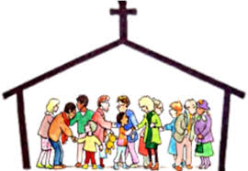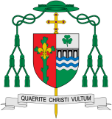

What makes people special?

**OUR BIG QUESTION**

What is good news?

REFLECTION

Lord, you fulfilled the hope of Simeon who did not die until he had been privileged to welcome the Messiah.

In Sacramental Celebrations we meet the Risen Christ. May he continue to give us life.

Amen.

**This Topic learning outcomes are to know and understand:**

• That there are special people in our lives who are there to help us – Explore

• That on Sunday, in church, we meet people who do special jobs as we gather to celebrate the

Good News of Jesus – Reveal

On Sunday, in church, we meet people who do special jobs as we gather to celebrate the Good News of Jesus. As in any family there are people who have special roles within the parish.

**Key Questions**

What makes a person special?

Who are the special people in our families and why?

Who are the people who have special roles in our parish family?

What were special times for Jesus?

**KEY VOCABULARY**

church community temple altar servers special ministers readers choir priest

**Scripture** Ephesians 2:10

We are God’s work of art, created in Christ Jesus to live the good life as from the beginning he had meant us to live it.

Special People

All families who live or worship in a parish are part of the parish family.

Missionary Disciples