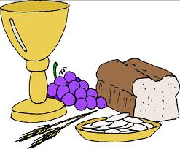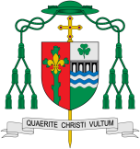

**This Topic learning outcomes are to know and understand:**

• Families and groups share special meals – Explore

• Mass as Jesus’ special meal – Reveal

REFLECTION

Lord Jesus Christ, in you we know the love of God. When we gather in your name, we experience the marvel of your loving presence which challenges us to live for one another. Help us to follow your example so that we may never become complacent. Help us to listen to your constant call to us to continue the work you began, you who lived and died for us.

Grant this through your Spirit of Love.

Amen.

**Scripture** 1 Cor. 11: 26

Whenever you eat this bread, and drink this cup you are proclaiming the Lord’s death until he comes.

Meals

The parish family gathers for the Eucharist (Mass), Jesus’ special meal.

Encounter

**OUR BIG QUESTION**

What is good news?

**KEY VOCABULARY**

family meal Mass share blessing bread host

wine altar

Last Supper

**Key Questions**

What happens at a meal?

What makes some meals special?

What makes some meals special?

We find strength in gathering for the celebration of the Eucharist and of God’s love in our lives. There is joy in gathering together to celebrate Mass.