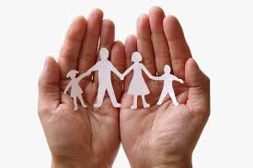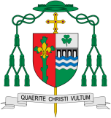

**Scripture** Colossians 3: 12, 14

You are the people of God; he loved you and chose you for his own. So then you must clothe yourselves with compassion, kindness, humility, gentleness and patience… And to all these qualities add love, which binds all things together in prefect unity.

Families

Everyone belongs to the family of God. It is in the love of a family that Christians first experience the reality of Church.

REFLECTION

Father, creator of all, you ‘ordered the earth’ to bring forth life and crowned its goodness by creating family life. Teach us the beauty of human love, show us the value of family life and help us to live in peace with everyone.

Amen.

Discipleship

**OUR BIG QUESTION**

What is good news?

**KEY VOCABULARY**

Family, belong, God, love, care, different,

God’s children, psalm, family of God, responsefamily

**Key Questions**

Who loves me? Who are my family? How do families show love and care?

How do families show love and care?

**This Topic learning outcomes are to know and understand:**

*The love and care shown in the family

* God’s love and care for every family

It is in the love of a family that Christians first experience the reality of Church. The family is the community in which from childhood we can learn moral values, begin to honour God and make good use of freedom.