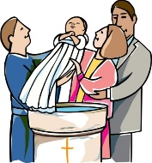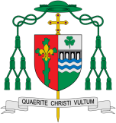

**This Topic learning outcomes are to know and understand:**

* That we belong to different groups

• That Baptism is an invitation to belong to God’s family

**Key Questions**

How do we show people that they are welcomed?

How is a baby welcomed into a family?

How are we welcomed into God’s family?

Baptism makes us members of the Body of Christ: ‘Therefore… we are members one of another.’ Baptism enables people to belong to God’s family in a special way. Christians believe that everyone is invited to share in the life and work of God through Baptism.

**KEY VOCABULARY**

Sign of the Cross belong friends sacrament invitation welcome Baptism God-parents sign

What does it mean to belong?

**OUR BIG QUESTION**

What is good news?

**Scripture**: Matthew 28:19

Go therefore and make disciples of all nations, baptising them in the name of the Father and of Son and of the Holy Spirit.

REFLECTION

Almighty and eternal God, you keep together those you have united. Look kindly on all who follow Jesus your Son. We are all consecrated to you by our common baptism; make us one in the fullness of faith and keep us one in the fellowship of love.

Amen.

Belonging

Christians believe that everyone is invited to share in the life and work of God through Baptism.

Encounter