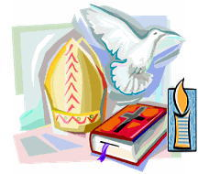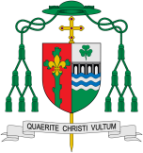

REFLECTION

Almighty and eternal God, you keep together those you have united. Look kindly on all who follow Jesus your Son. We are all consecrated to you by our common baptism; make us one in the fullness of faith and keep us one in the fellowship of love.

Amen.

Through Baptism and Confirmation people are given the gift of the Holy Spirit and are called to respond in their lives. Confirmation is the full outpouring of the Holy Spirit as granted to the apostles on the day of Pentecost. The oil used in the sacramental celebration is called Chrism, consecrated by the bishop during the Chrism Mass on Holy Thursday.

This links to: The Hymn – Come Holy Spirit and the words of Oscar Romero

**This Topic learning outcomes are to know and understand:**

* The response to being chosen

*Confirmation: a call to witness

**KEY VOCABULARY**

Sacrament of Confirmation

oil of Chrism mitre

crozier sponsor Holy Trinity bishop

How do people respond to being called?

**OUR BIG QUESTION**

What is good news?

**Scripture**: Mark 1: 10-11

As Jesus was coming up out of the water, he saw ... the spirit descending like a dove on him. And a voice came from heaven, ‘You are my son, the beloved, with you I am well pleased’.

Vocation

**Key Questions**

How does it feel to be chosen?

How do people respond to being called?

Called

The first “profession of faith” is made during Baptism.