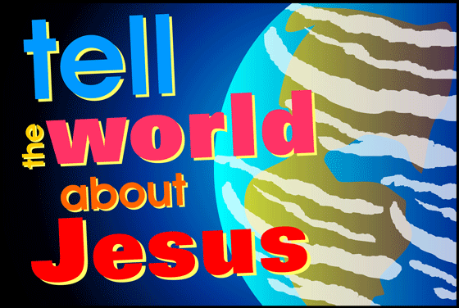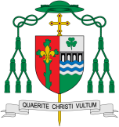

**Scripture** Mark 3: 13-15

Jesus went up the mountain and called to him those whom he wanted, and they came to him. And he appointed twelve, whom he also named apostles to be with him, and to be sent out to proclaim the message and to have authority to cast out demons.

**Key Questions**

What inspires people in their mission?

What are the joys and demands of engaging in a mission?

What unites Christian communities?

**This Topic learning outcomes are to know and understand:**

•The mission of inspirational leaders – Explore

• Dioceses continue the work and mission of Jesus including ecumenism – Reveal

Mission

The Church, the Christian family, is made up of smaller Christian families called dioceses. Each diocese is led by a bishop.

REFLECTION

Lord, you fulfilled the hope of Simeon who did not die until he had been privileged to welcome the Messiah.

In Sacramental Celebrations we meet the Risen Christ. May he continue to give us life.

Amen.

Missionary Disciples

**OUR BIG QUESTION**

What is good news?

**KEY VOCABULARY**

ecumenism cathedral diocese Christian Unity Gentile inspired service missalministers readers choir priest

Do we all have a mission?

The bishops continue the work of ‘the twelve’, the apostles, who continued the work and mission of Jesus. Jesus is the head of these families. He is the head of the Church. There are other Christian families which are not part of the Catholic Church. Ecumenism is the word used for promoting unity among Christian churches. One of the final prayers of Jesus was that all Christian families might be one.