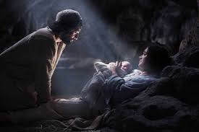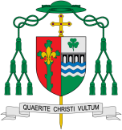

**This Topic learning outcomes are to know and understand:**

* Waiting hopefully

*Advent is the Church’s season of waiting in joyful hope for the coming of Jesus, the promised One, at Christmas and at the end of time

Hope

When the Church celebrates the liturgy of Advent each year, she makes present this ancient expectancy of the Messiah, for by sharing in the long preparation for the Saviour’s first coming, the faithful renew their ardent desire for his second coming.

**Scripture** Luke 2:8-12 In that region there were shepherds living in the fields keeping watch over their flock by night. Then an angel of the Lord stood before them and the glory of the Lord shone around them, and they were terrified. But the angel said to them, “Do not be afraid; for see – I am bringing you good news of great joy for all the people: to you is born this day in the city of David a saviour, who is the Messiah, (The Christ) the Lord. This will be a sign for you: you will find a child wrapped in bands of cloth and lying in a manger.”

**Key Questions**

What is the hidden meaning in waiting?

What is the difference between hope and expect??

REFLECTION

Today a Saviour is born! In the stillness of the night God enters human history through the birth of his only Son. He is our peace and hope. In him we praise God for his

goodness to us in giving us so great a gift.

Amen.

Encounter

**OUR BIG QUESTION**

What is good news?

**KEY VOCABULARY**

waiting hopeful Promised one

Messiah prophet

What does it mean to live in hope?

Advent focuses on Jesus’ coming in history and encourages believers to prepare for the Christ who comes each day. Christians celebrate the birth of Jesus, the promised one, on 25 December. It is preceded by the season of Advent, a time of preparation. The church is sharing in the long preparation for the Saviour’s first coming, the faithful renew their ardent desire for his second coming.