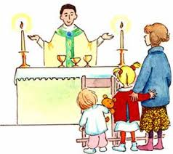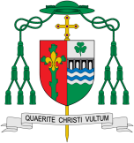

The parish family finds strength in gathering for the celebration of the Eucharist, a sign of God’s love in our lives. We share memories, love and thanks as we celebrate the Life, Death and Resurrection of Jesus.

Our Big Question

Why do people gather together?

**This Topic learning outcomes are to know and understand:**

• How and why people gather together – Explore

• The joy of gathering together to celebrate at Mass – Reveal

REFLECTION

Lord Jesus Christ, in you we know the love of God. When we gather in your name, we experience the marvel of your loving presence which challenges us to live for one another. Help us to follow your example so that we may never become complacent. Help us to listen to your constant call to us to continue the work you began, you who lived and died for us.

Grant this through your Spirit of Love.

Amen.

**Scripture** 1 Cor. 12: 27

Now you together are Christ’s body; but each of you is a different part of it.

Gathering

The parish family finds strength in gathering for the celebration of the Eucharist, a sign of God’s love in our lives.

Encounter

**KEY VOCABULARY**

welcome, blessing, listen, pray, Mass, sing, gather, together, alone

**Key Questions**

What things are better done together?

Why are they better with others?