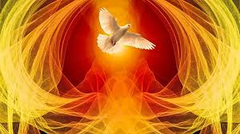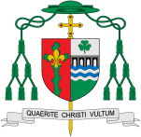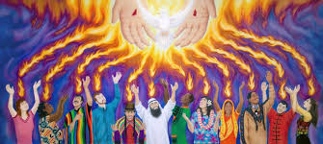

What is the use of energy?

**This Topic learning outcomes are to know and understand:**

*How the Church celebrates Pentecost

*How the Holy Spirit energies us

* That we all receive the gifts of the Holy Spirit

**OUR BIG QUESTION**

Why should we spread good news?

**Scripture** : 1 Cor 12:4-6

There are different kinds of spiritual gifts, but the same Spirit gives them. There are different ways of serving, but the same Lord is served. There are different abilities to perform service, but the same God gives ability to all for their particular service.

Missionary Discipleship

Energy

In this topic we will be learning all about the power and wonder of the Holy Spirit

**KEY VOCABULARY**

warmth wind energy power gifts

Holy Spirit Rosary

Glorious Mysteries

Christians believe that the gift of the Holy Spirit within them gives them energy and the power to live the way of Jesus. As we celebrate Pentecost we remember the many gifts that the Holy Spirit gives to us all and how the power of the Holy Spirit energies us to make changes in our lives.

**Key Questions**

How can the energy of the wind be used for good? How the Holy Spirit inspires Christians?

REFLECTION

Father, pour out your Spirit upon your people,

and grant us a new vision of your glory,

a new faithfulness to your Word and a new

consecration to your service, that your love

may grow among us, and your kingdom

come: through Christ our Lord.

Amen.