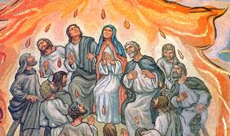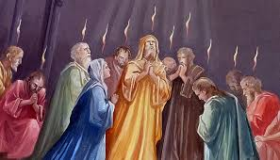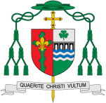

**This Topic learning outcomes are to know and understand:**

*How the Holy Spirit enables people to witness to the Easter message

* About modern witnesses to the power of the Holy Spirit.

*Recognising ourselves as witnesses using the power of the Holy Spirit.

**Scripture**: Acts 2:14, 32-33

Peter standing with the eleven, raised his voice and addressed them: ‘Men of Judea and all who live in Jerusalem let this be known to you, and listen to what I say. This Jesus God raised up, and of that all of us are witnesses. Being therefore exalted at the right hand of God and having received from the Father the promise of the Holy Spirit, he has poured out this that you both see and hear.

Christians believe that the spirit of God is active in each person and in a special way in the community of believers which is the Church. The Feast of Pentecost is the celebration both of the gift of God’s Holy Spirit and the trust God places in people to be witnesses in the world.

Catechism of the Catholic Church 767: ‘When the work which the Father gave the Son to do on earth was accomplished the Holy Spirit was sent on the day of Pentecost in order that he might continually sanctify the church.’ Then the church was openly displayed to the crowds and the spread of the gospel among the nations, through preaching, was begun.

Witnesses

In this topic we will be learning all about how the Feast of Pentecost is the celebration both of the gift of God’s Holy Spirit and the trust God places in people to be witnesses in the world.

What do I want to witness in my life?

**OUR BIG QUESTION**

Why should we spread good news?

Missionary Discipleship

**KEY VOCABULARY**

Holy Spirit martyrs courage

truth inspiration Good News

**Key Questions**

Why does it sometimes need courage to be a witness? How do you know when to speak out?

REFLECTION

Father, pour out your Spirit upon your people,

and grant us a new vision of your glory,

a new faithfulness to your Word and a new

consecration to your service, that your love

may grow among us, and your kingdom

come: through Christ our Lord.

Amen.