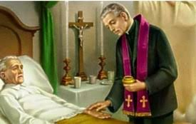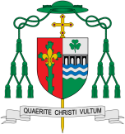

**Key Questions**

Why do we care for the sick? Why do people give time and commitment for caring for others? What gives a person comfort when they are very ill?

**This Topic learning outcomes are to know and understand:**

*When people become sick and need care

*The Sacrament of the Anointing of the Sick

**Scripture :** James 5:14-15 Are any among you sick? They should call for the elders of the church and have them pray over them, anointing them with oil in the name of the Lord. The prayer of faith will save the sick and the Lord will raise them up; and anyone who has committed sins will be forgiven.

**KEY VOCABULARY**

care sickness hospice compassion

Sacrament anointing Lourdes

Healing

The Church believes that the anointing of the sick is one the seven sacraments. It is intended to strengthen those who are ill. The sacrament of anointing of the sick is given to those who are seriously ill by anointing them on the forehead and hands with duly-blessed oil.

Discipleship

**OUR BIG QUESTION**

What is good news?

Who needs healing?

The sacrament of anointing of the sick is given to those who are seriously ill by anointing them on the forehead and hands with duly-blessed oil – pressed from olives or from other plants – saying, only once: ‘Through this holy anointing may the Lord in his love and mercy help you with the grace of the Holy Spirit. May the Lord who frees you from sin save you and raise you up.’

REFLECTION

I have chosen the way of faithfulness; I set your ordinances before me.

I cling to your decrees, O Lord; let me not be put to shame.

I run the way of your commandments, for you enlarge my understanding.

Teach me, O Lord, the way of your statutes, and I will observe it to the end.

Give me understanding that I may keep your law and observe it with my whole heart.

Amen.