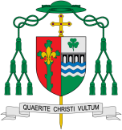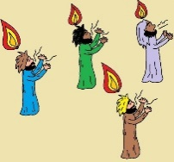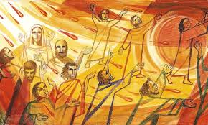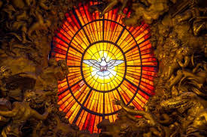

**OUR BIG QUESTION**

Do we need holidays and holydays?

Missionary Discipleship

Holidays and Holydays

In this topic we will be learning all about Pentecost and how the gift of the Holy Spirit is given.

**Key Questions**

How do I use holiday times to relax and do something different?

How does the Holy Spirit help and guide us in our lives?

**KEY VOCABULARY**

holiday, holyday, Apostles, help, Pentecost, promise, Holy Spirit, guide, Resurrection, alleluia

**Scripture** John 14: 26, John 13: 33; 14:18, Acts 2: 1-4

The Helper, the Holy Spirit whom the Father will send in my name will teach you everything and make you remember all that I have toldyou.

Some children will be able to recognise what a holy day is and the story of coming of the Holy Spirit at Pentecost.

Some children will be able to recognise some symbols of the Holy Spirit.

Some children will be able to retell the story of the coming of the Holy Spirit at Pentecost.

Some children will be able to describe the ways in which the Holy Spirit is a helper and guide.

The word holiday comes from holyday. In times past the only holiday anyone had was a saint’s feast day or important feast days like Easter and Christmas. Some days of the year are ‘holy days’, when we celebrate these special times in the Church’s year.

Pentecost is a special day that Christians celebrate. Pentecost is often named as the ‘birthday of the Church’.

REFLECTION

Father, pour out your Spirit upon your people,

and grant us a new vision of your glory,

a new faithfulness to your Word and a new

consecration to your service, that your love

may grow among us, and your kingdom

come: through Christ our Lord.

Amen.