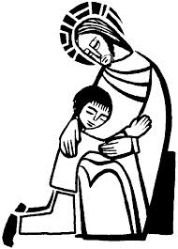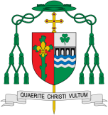

**KEY VOCABULARY**

choice, happy, sad, disappointed, sorry, forgive rules, wrong, right, feeling, love, Sign of Peace, Peace be with you

**Scripture Luke 15: 20-21** . . . so he left the place and went back to his father. While he was a long way off, his father saw him and was moved with pity. He ran to the boy, clasped him in his arms and kissed him. Then his son said, ‘Father I have sinned against heaven and you’.

Being Sorry

For Christians it is important to make choices in the light of our belief in a loving God. There are times when we need to acknowledge our sorrow for making wrong choices. The Church offers the Sacrament of Reconciliation which celebrates God’s unconditional love for us.

Discipleship

**OUR BIG QUESTION**

What is good news?

**Key Questions**

What are some good choices you have made? What are some bad choices you have made? How did you feel?

How do you show you are sorry?

**This Topic learning outcomes are to know and understand:**

* We have choice – sometimes we choose well, and sometimes wrongly

*God helps us to choose well and to be sorry. God forgives us

We all make mistakes and in this topic we learn how Jesus can help us when we make the wrong decision. The children will learn about how and why they can say sorry and how this helps them to rebuild their relationship with others and with God. We learn that Jesus forgives us when we make mistakes and teaches us how to try better and to show love to everyone that we meet.

REFLECTION

I have chosen the way of faithfulness; I set your ordinances before me.

I cling to your decrees, O Lord; let me not be put to shame.

I run the way of your commandments, for you enlarge my understanding.

Teach me, O Lord, the way of your statutes, and I will observe it to the end.

Give me understanding that I may keep your law and observe it with my whole heart.

Amen.