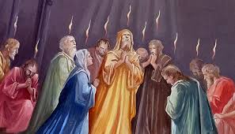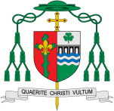

New Life

In this topic we will be learning all about how the new life of the Easter message is spread through the power of the Holy Spirit

What is so important about new life?

**This Topic learning outcomes are to know and understand:**

*How the Holy Spirit gave courage to Peter and John

* The story of Paul and how he spread the Good News

**OUR BIG QUESTION**

Why should we spread good news?

**Scripture**: Acts 2:1-4

When the day of Pentecost had come, they were all together in one place… All of them were filled with the Holy Spirit and began to speak in other languages, as the Spirit gave them ability.

Missionary Discipleship

**KEY VOCABULARY**

life, good news, Resurrection, Pentecost, Holy Spirit, fellowship

Christians believe that the Spirit of God is active in each person and, in a special way, in the community of believers, which is the Church. Christ as head of the body, pours out the Spirit among his members to nourish, heal and organise them in their mutual functions, to give them life, send them to bear witness, and associate them to his self-offering to the Father and to his intercession for the whole world.

**Key Questions**

How can good news change the way you feel? How good news can bring life?

REFLECTION

Father, pour out your Spirit upon your people,

and grant us a new vision of your glory,

a new faithfulness to your Word and a new

consecration to your service, that your love

may grow among us, and your kingdom

come: through Christ our Lord.

Amen.