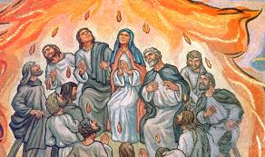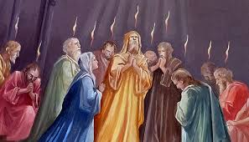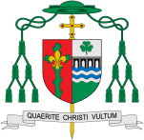

Christians believe that the Spirit of God is active in each person and in a special way in the community of believers, which is the church. Catechism of the Catholic Church 696: fire symbolises the transforming energy of the Holy Spirit’s actions. The prayer of the prophet Elijah, who ‘arose like fire’ and whose word ‘burned like a torch’ brought down fire from Heaven on the sacrifice on Mount Carmel. This event was a ‘figure’ of the fire of the Holy Spirit who transforms what he touches. John the Baptist who goes ‘before (the Lord) in the spirit and power of Elijah’, proclaims Christ as the one who ‘will baptise you with the Holy Spirit and with fire’. … In the form of tongues ‘as of fire’, the Holy Spirit rests on the disciples on the morning of Pentecost and fills them with himself.

Transformation

In this topic we will be learning all about how it is the work of the Spirit to enable people to hear God’s message, to respond and share it.

How can energy transform?

**This Topic learning outcomes are to know and understand:**

*How Pentecost is the celebration of the Spirit’s transforming power

* How Saul was transformed by the Holy Spirit

*The Fruits of the Sprit and how these can transform these in out lives

**OUR BIG QUESTION**

Why should we spread good news?

**Scripture**: Acts 1:8

But you will receive power when the Holy Spirit has come upon you; and you will be my witnesses in Jerusalem, in all Judea and Samaria and to the ends of the earth.

Missionary Discipleship

**KEY VOCABULARY**

transform energy Holy Spirit change

Gift Fruits of the Spirit

**Key Questions**

How can I transform my energy for the good of others? How energy can transform?

REFLECTION

Father, pour out your Spirit upon your people,

and grant us a new vision of your glory,

a new faithfulness to your Word and a new

consecration to your service, that your love

may grow among us, and your kingdom

come: through Christ our Lord.

Amen.