**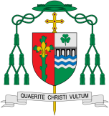****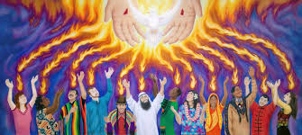**

**Scripture** Acts 2: 1-4

**When the day of Pentecost came, all the believers were gathered together in one place.**

**OUR BIG QUESTION**

What is good news?

Missionary Discipleship

Good News

In this topic we will be learning all about Pentecost and how the gift of the Holy Spirit is given.

**This Topic learning outcomes are to know and understand:**

*That everyone has Good News to share

*Pentecost: the celebration of the Good News of Jesus

Pentecost is often named as the ‘birthday of the Church’. The feast celebrates the coming of the Holy Spirit to the disciples. The Holy Spirit is a new friend that Jesus had promised to send them. With a new friend the disciples felt full of joy and happiness. They were no longer frightened and were able to go out and share the Good News with others.

**Key Questions**

What is Good News?

Who is the Holy Spirit?

**KEY VOCABULARY**

share, Good News, Pentecost, promise, Holy Spirit, Easter, Alleluia,

REFLECTION

Father, pour out your Spirit upon your people,

and grant us a new vision of your glory,

a new faithfulness to your Word and a new

consecration to your service, that your love

may grow among us, and your kingdom

come: through Christ our Lord.

Amen.