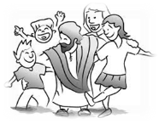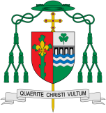

We all have very important friends and in this topic the children are reminded that Jesus is our friend. They will be looking at how we can make friends with people and how we can show love to our friends. Within the topic we will be looking at what happens when we hurt our friends and how we can say sorry to them to reconcile the relationship.

**Scripture** John 15:15

Jesus says, I call you friends

**Mark 6: 7, 30-32** **John 13: 34** **John 13: 34-35**

Our Big Question

Is it good to have friends?

Discipleship

Friends

Relationships bring both joy and challenge. . Through Christ we are offered the power to forgive and make peace and to receive and offer reconciliation. Relationships bring both joy and challenge.

**KEY VOCABULARY**

friend, happy, sad, love, make up, kind, gentle, loving, sorry, Jesus, forgive, change

**Key Questions**

Who are your friends?

Why are they your friends?

Are you anyone’s friend?

**This Topic learning outcomes are to know and understand:**

*That Jesus is friends with everyone and He loves us

*How we can show love to our friends

REFLECTION

I have chosen the way of faithfulness; I set your ordinances before me.

I cling to your decrees, O Lord; let me not be put to shame.

I run the way of your commandments, for you enlarge my understanding.

Teach me, O Lord, the way of your statutes, and I will observe it to the end.

Give me understanding that I may keep your law and observe it with my whole heart.

Amen.