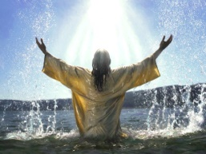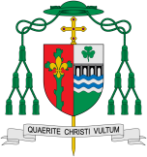

The promises made at Baptism and Confirmation are the call to a new way of life. Belonging to a group involves promises and rules.

This links to: The Sign of the Cross and the Hymn – Walk in the Light

**This Topic learning outcomes are to know and understand:**

* Belonging to a group involves promises and rules

*The meaning of the promises made at Baptism

**KEY VOCABULARY**

Promises, rules, actions, symbols, rite, Sacrament, commitment, faith, welcome, Church, ceremonies, Chrism, anointing, Trinity

What makes a promise?

**OUR BIG QUESTION**

What is good news?

**Scripture**: Galatians 3:27

You were baptised into union with Christ, and now you are clothed, so to speak, with the life of Christ himself.

Encounter

REFLECTION

Almighty and eternal God, you keep together those you have united. Look kindly on all who follow Jesus your Son. We are all consecrated to you by our common baptism; make us one in the fullness of faith and keep us one in the fellowship of love.

Amen.

**Key Questions**

What does it mean to make a promise?

How can we help others keep promises?

Promises

The first “profession of faith” is made during Baptism.