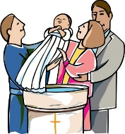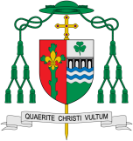

The sacraments are actions and signs, which deepen communion with God the Father, Son and Holy Spirit. At Baptism, the church invites and welcomes the person into the church family. The Sacrament of Baptism is the basis of all Christian life.

Our Big Question

Why is being welcomed important?

**Key Questions**

How do we show people that they are welcomed?

How is a baby welcomed into a family?

How are we welcomed into God’s family?

**Scripture**: John 15: 9

I love you just as the Father loves me; remain in my love.

REFLECTION

Almighty and eternal God, you keep together those you have united. Look kindly on all who follow Jesus your Son. We are all consecrated to you by our common baptism; make us one in the fullness of faith and keep us one in the fellowship of love.

Amen.

Encounter

Welcome

Through Baptism we are welcomed into God’s loving family.

**KEY VOCABULARY**

welcome welcomed Baptism baptise water candle Priest Font Godparents family

**This Topic learning outcomes are to know and understand:**

* That God knows and loves each one

*That God knows each person’s name.