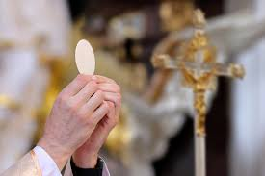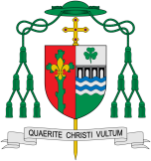

**This Topic learning outcomes are to know and understand:**

• Different ways to say thank you – Explore

• The Eucharist: the parish family thanks God for Jesus – Reveal

REFLECTION

Lord Jesus Christ, in you we know the love of God. When we gather in your name, we experience the marvel of your loving presence which challenges us to live for one another. Help us to follow your example so that we may never become complacent. Help us to listen to your constant call to us to continue the work you began, you who lived and died for us.

Grant this through your Spirit of Love.

Amen.

**Scripture** 1 Cor. 11: 23-24

Jesus on the night he was betrayed, took a piece of bread, gave thanks to God, broke it, and said, ‘This is my body, which is for you. Do this in memory of me.’

Thanksgiving

The word Eucharist means ‘thanksgiving’.

Encounter

**OUR BIG QUESTION**

What is good news?

**KEY VOCABULARY**

thank you, thanksgiving, thoughtful, Eucharist, Eucharistic Prayer, liturgy, Last Supper

**Key Questions**

Why it is important to say thank you?

How it feels to say thank you?

How it feels to be thanked?

What should we be grateful for?

The parish family gathers to give thanks to God, most of all for the gift of Jesus, his Son. The Eucharist is another name for the Mass.