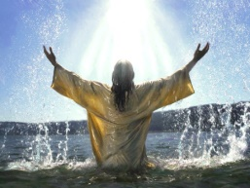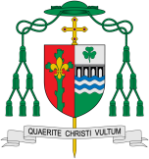

Special symbols are called ‘sacraments’ because they put us in touch in a powerful way with the life, ministry, death and resurrection of Jesus and they point to his continued presence among us today.

**This Topic learning outcomes are to know and understand:**

* Experience of signs and symbols

* Signs and symbols used in Baptism

**KEY VOCABULARY**

garment, Easter candle, font, chrism, Good News sign, symbols

Are signs and symbols important?

**OUR BIG QUESTION**

What is good news?

**Scripture**: John 3:5

‘I am telling you the truth,’ replied Jesus. ‘No one can enter the Kingdom of God without being born of water and the Spirit.’

Encounter

REFLECTION

Almighty and eternal God, you keep together those you have united. Look kindly on all who follow Jesus your Son. We are all consecrated to you by our common baptism; make us one in the fullness of faith and keep us one in the fellowship of love.

Amen.

**Key Questions**

How do symbols have power to convey meaning?

Why are some symbols important?

How do Christians maintain the light of Christ in their lives?

Signs and Symbols

For Christians, signs and symbols speak of God’s mysterious presence in the world and in our lives.