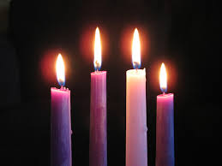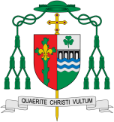

Preparations

Advent is a time we consider how we can prepare ourselves for the coming of Jesus

**Scripture** Isaiah 40: 3, 5-6

A voice cries out, ‘Prepare in the wilderness a road for the Lord! Clear the way in the desert for our God!... Then the glory of the Lord will be revealed, and the whole human race will see it. The Lord himself has promised this.’

REFLECTION

Today a Saviour is born! In the stillness of the night God enters human history through the birth of his only Son. He is our peace and hope. In him we praise God for his

goodness to us in giving us so great a gift.

Amen.

Encounter

**OUR BIG QUESTION**

What is good news?

**KEY VOCABULARY**

preparing, Advent, Christmas, Nativity, waiting, Annunciation, Visitationmanger wreath

**Key Questions**

Why is it necessary to prepare?

Do we need to prepare?

**This Topic learning outcomes are to know and understand:**

* How we can prepare for special times

• Advent four weeks of preparation for the celebration of Jesus at Christmas l

God had prepared His people for the coming of His Son, the Messiah over many hundreds of years. Advent is a time of preparation to celebrate Jesus’ first coming on earth. Advent also reminds people that he will come again at the end of time.