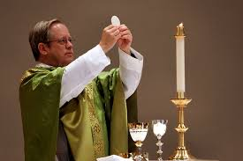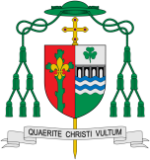

**Key Questions**

What is so important about listening and sharing?

What is the cost of listening and sharing?

**KEY VOCABULARY**

listening, sharing, Eucharist, Mass, gathering, Liturgy of the Word, Liturgy of the Eucharist, Holy Communion, Good News, ambo

**This Topic learning outcomes are to know and understand:**

• Listening and sharing with one another – Explore

• Listening to the Word of God and sharing in Holy Communion – Reveal

REFLECTION

Lord Jesus Christ, in you we know the love of God. When we gather in your name, we experience the marvel of your loving presence which challenges us to live for one another. Help us to follow your example so that we may never become complacent. Help us to listen to your constant call to us to continue the work you began, you who lived and died for us.

Grant this through your Spirit of Love.

Amen.

**Scripture** 1 Cor 11: 23-25 The Lord Jesus, on the night he was betrayed, took a piece of bread, gave thanks to God, broke it and said, “This is my body, which is for you. Do this in memory of me.” In the same way, after supper he took the cup and said “This cup is God’s new covenant sealed with my blood. Whenever you drink it, do so in memory of me.”

Listening and Sharing

The Eucharistic celebration consists of two parts.

Encounter

**OUR BIG QUESTION**

What is good news?

What is so important about listening and sharing?

The first part of the Eucharist s the Liturgy of the Word, where Christians listen to God’s Word in the readings, listen to the homily and the prayers of the Faithful. The second part of the celebration is the Liturgy of the Eucharist. Here the gifts are prepared, the Eucharistic prayer expresses thanksgiving and Communion is shared. The Liturgy of the Word and Liturgy of the Eucharist together form “one single act of worship”.