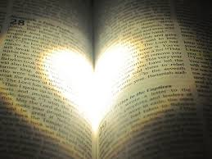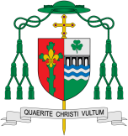

**Scripture** 1 Thessalonians 2:13

We also constantly give thanks to God ... that when you received the word of God that you heard from us, you accepted it not as a human word but as what it really is, God’s word which is also at work in you believers.

**Key Questions**

How are our lives are enriched by books?

The wonder of books and how they take a person beyond themselves

**This Topic learning outcomes are to know and understand:**

• A wide variety of books and the purpose for which they were written – Explore

• The Bible as the story of God’s love, told by the People of God – Reveal

Sources

The Bible is the story, spread over more than two thousand years, of God’s love and how God’s people responded to that love.

REFLECTION

Lord, you fulfilled the hope of Simeon who did not die until he had been privileged to welcome the Messiah.

In Sacramental Celebrations we meet the Risen Christ. May he continue to give us life.

Amen.

Missionary Disciples

**OUR BIG QUESTION**

What is good news?

**KEY VOCABULARY**

Bible Old Testament New Testament

genre prose history missalministers readers choir priest

Are books enriching?

There are all sorts of people in the Bible – good, bad and indifferent – just as in the world today. God showed his love for them by wonderful deeds and each responded in a special way. There are all kinds of writings and the authors

all wanted to tell us one thing: the truth about God. All of them were inspired by the Holy Spirit when they were writing. This is why the church family believes that the Holy Spirit is also the author of the Bible.