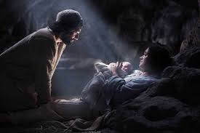****

**This Topic learning outcomes are to know and understand:**

* The meaning of expectation

*Advent, a time of joyful expectation of Christmas, the Word becoming a human person, Jesus

Exectations

Advent is a time of joyful expectation, as we prepare to receive Jesus into our lives

**Scripture** John 14:9-10

Jesus said to him, ‘Have I been with you all this time, Philip, and you still do not know me? Whoever has seen me has seen the Father. How can you say, ‘Show us the Father? Do you not believe that I am in the Father and the Father is in me? The words that I say to you I do not speak on my own; but the Father who dwells in me does his works.’

**Key Questions**

What is the role of patience in expectations?

What is the difference between I wish for and I expect?

REFLECTION

Today a Saviour is born! In the stillness of the night God enters human history through the birth of his only Son. He is our peace and hope. In him we praise God for his

goodness to us in giving us so great a gift.

Amen.

Encounter

**OUR BIG QUESTION**

What is good news?

**KEY VOCABULARY**

Expectation, certainty, Advent, Christmas

Emmanuel, Annunciation, Angelus,

Incarnation

Should we have expectations?

Christians celebrate the birth of Jesus, given by God as a sign and expression of God’s love. Giving and receiving reflects the truth that all life is given by God and life is given meaning through the birth of Jesus. Advent is a time of joyful expectation, as we prepare to receive Jesus into our lives and to share this gift with others at Christmas and throughout the year.