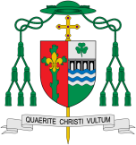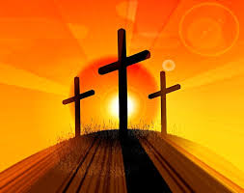

Missionary Disciples

Death and New Life

For Christians, it is through the Life, Death and Resurrection of Jesus that new life begins. Jesus reveals the way to eternal life for us and so a new life begins here and now, a life which will culminate in future glory.

**This Topic learning outcomes are to know and understand:**

Loss and death bring about change for people

The Church’s seasons of Lent, Holy Week and Easter; the suffering, death and resurrection of Jesus led to new life

Acquire the skills of assimilation, celebration and application of the above

**KEY VOCABULARY**

giving, carer, cost, temptation, betrayal, self-sacrifice, Holy Week, Maundy Thursday, Gethsemane, Altar of Repose, love, crucifixion, Easter vigil, Resurrection

**Key Questions**

Why does loss and death bring about change?

How do people cope with loss and death?

REFLECTION

Lord, when I am hungry give me someone to feed; When I am thirsty give water for their thirst. When a burden weighs upon me lay upon my shoulders the burden of my fellows.

Lord, when I stand greatly in need of tenderness, give me someone who yearns for love. May your will be my bread; Your grace my strength; Your love my resting place.

Amen

**Scripture** John 12:24

Very truly, I tell you, unless a grain of wheat falls into the earth and dies, it remains just a single grain; but if it dies it bears much fruit.

**OUR BIG QUESTION**

What is good news?

Can any good come from loss and death?

Catechism of the Catholic Church 638: ‘We bring you the good news that what God promised to the fathers, this day he has fulfilled to us their children by raising Jesus.’ The Resurrection of Jesus is the crowning truth of our faith in Christ, a faith believed and lived as the central truth by the first Christian community; handed on as fundamental by Tradition; established by the documents of the New Testament and preached as an essential part of the Paschal mystery along with the cross: Christ is risen from the dead! Dying, he conquered death; to the dead, he has given new life.