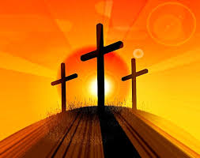

**Key Questions**

How have you changed since you were a baby? What do you know now that you did not know when you were younger?

How do you show kindness and sharing now that you

are older?

**This Topic learning outcomes are to know and understand:**

That we change and grow

Lent; a time to change in preparation for the celebration of Easter

Acquire the skills of assimilation, celebration and application of the above

**Scripture** John 12:24

Unless a grain of wheat falls into the earth and dies, it remains just a single grain, but if it dies it bears much fruit..

REFLECTION

Lord, when I am hungry give me someone to feed; When I am thirsty give water for their thirst. When a burden weighs upon me lay upon my shoulders the burden of my fellows.

Lord, when I stand greatly in need of tenderness, give me someone who yearns for love. May your will be my bread; Your grace my strength; Your love my resting place.

Amen

Change

Lent is a time to work at growing spiritually in preparation to celebrate the death of Jesus and his resurrection at Easter.

Missionary Disciples

**OUR BIG QUESTION**

What is good news?

**KEY VOCABULARY**

change seasons spring growth Lent Ash Wednesday Good Friday Easter Sunday Alleluia Cross Resurrection

How and why do things change?

Lent offers a time to reflect on life and change. This is a time to prepare for Easter. Change is a necessary part of healthy growth.