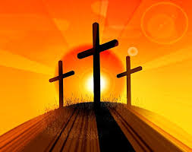

**Key Questions**

How can I be self-disciplined in the choices I make?

How will self-discipline help me to grow and to reach my full potential?

**KEY VOCABULARY**

self-discipline, effort, potential, penance, contrition, Lent, Easter, Resurrection, fasting, alms giving

REFLECTION

Lord, when I am hungry give me someone to feed; When I am thirsty give water for their thirst. When a burden weighs upon me lay upon my shoulders the burden of my fellows.

Lord, when I stand greatly in need of tenderness, give me someone who yearns for love. May your will be my bread; Your grace my strength; Your love my resting place.

Amen

**This Topic learning outcomes are to know and understand:**

Self-discipline is important – Explore

Celebrating growth to new life through self-discipline – Reveal

Acquire the skills of assimilation, celebration and application of the above – Respond

**Scripture** Matthew 7: 1-6

Do not judge, so that you may not be judged. For with the judgement you make you will be judged, and the measure you give will be the measure you get. Why do you see the speck in your neighbour’s eye, but you do not notice the log in your own?

Self Discipline

Lent is part of the Liturgical Year when people unite themselves with Christ.

Missionary Disciples

**OUR BIG QUESTION**

What is good news?

Is self-discipline important?

Lent is part of the Liturgical Year when people unite themselves with Christ. During Lent we grow in self-discipline through the practices of prayer, fasting and almsgiving. We celebrate growth of new life in Christ, in preparation for the feast of Easter.