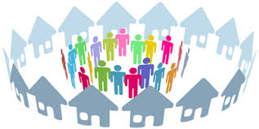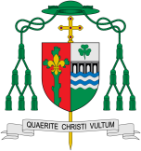

**Scripture** Romans 12:4-6

We have many parts in the one body, and all these parts have different functions ...we are many, we are one body in union with Christ ...we are use our different gifts in accordance with the grace that God has given us

**Key Questions**

Why do people give up their time to help others in the community? What makes communities function well for the good of others?

**This Topic learning outcomes are to know and understand:**

• Belonging to a community – Explore

• The life of the local Christian community – Reveal

Community

Lay people help to build up the local community of the parish.

REFLECTION

Lord, you fulfilled the hope of Simeon who did not die until he had been privileged to welcome the Messiah.

In Sacramental Celebrations we meet the Risen Christ. May he continue to give us life.

Amen.

Missionary Disciples

**OUR BIG QUESTION**

What is good news?

**KEY VOCABULARY**

responsibility parish laity ministries

pastoral area deanery service missalministers readers choir priest

What makes a community?

In the local church, lay people of all ages are called to undertake various roles called ministries by virtues of their Baptism and Confirmation. They help to build up the local community of the parish.