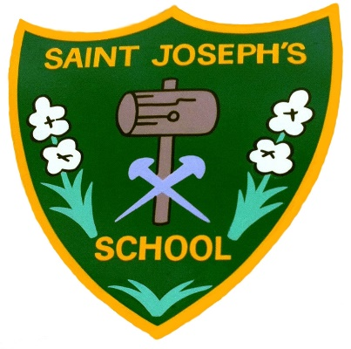**Saint Joseph’s Catholic**

**Primary School,**

**A Voluntary Academy**

**Our Lady of Lourdes Catholic Multi Academy Trust**

**Headteacher: Mrs D. Seaman**

**Langwith Road**

**Langwith Junction**

**Mansfield, Notts**

**NG20 9RP**

**Tel. & Fax. 01623 742609**

**email: enquiries@st-josephs-pri.derbyshire.sch.uk**

**www.stjosephscatholicprimaryvoluntaryacademy.co.uk**

**23rd May 2024**

Dear Parents,

Our new topic is called ‘Hola Mexico!. This focuses on Mexico including its geography including the climate and landscape and its history including the Mayan civilisation and the historical culture. To start this topic off in an exciting way, we are going to have our Launch Day on Monday 3rd June. We are going to complete different activities including learning about Mexico and taking part in some Mexican culture experiences.

To make this an exciting experience, the children are able to come dressed in the colours of the Mexican flag. These are red, white and green. These clothes don’t have to be new; they can be clothes you already have!

If there are any problems regarding this, please feel free to contact me at any point. Thank you for your continued support.

**Yours sincerely,**

**Miss Queenan** _______________________________________________________

“Every opportunity is taken to squeeze learning out of each minute. Pupils are articulate, confident, curious and ambitious to learn more.”

Ofsted September 2017