|  |  |  |
| --- | --- | --- |
| Right holders will…. | Our Rights…. | Duty Bearers Will…. |
| * Have calm discussions with each other * Use kind language * Share equipment fairly | We have the right to play and rest.  (Article 31) | * Make sure any arguments are dealt with effectively * Keep equipment in working order * Encourage sharing and taking it in turns |
| * Report any issues to a play leader * Speak honestly when reporting incidents | We have the right to give our opinions and for adults to listen and take this seriously.  (Article 12) | * Listen to all children’s concerns * Any serious issues will be discussed with a teacher after |
| * Use respectful language * Using equipment in the correct zones * Reflection area used appropriately | We have the right to live peacefully and have respect from others.  (Article 29) | * Have different areas to play with on the playground/field |
| * Report any incidents to a play leader * Use equipment properly | We have the right to be protected from being hurt or mistreated in body and mind.  (Article 19) | * Take all incidents seriously * Speak to children who aren’t using equipment properly |

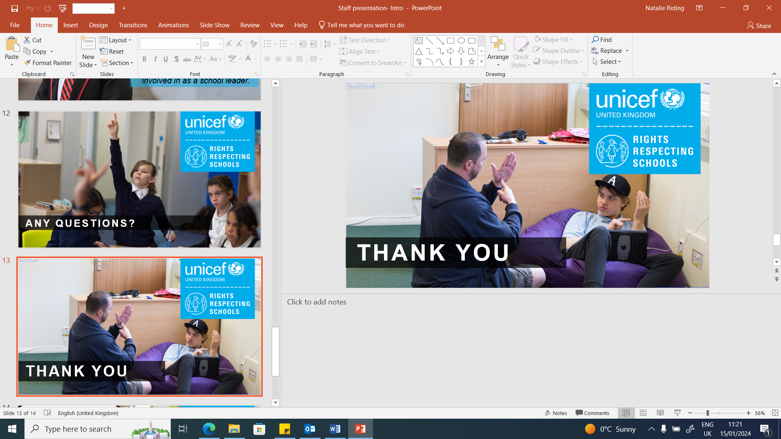St Joseph’s Playground Charter