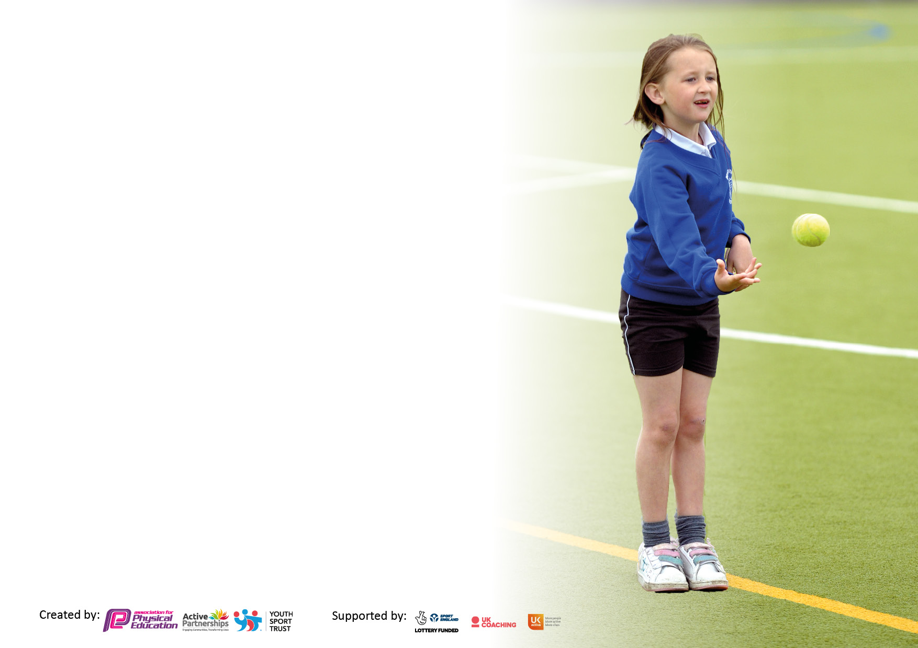

It is important that your grant is used effectively and based on school need. The Education Inspection Framework makes clear there will be a focus on **‘whether leaders and those responsible for governors all understand their respective roles and perform these in a way that enhances the effectiveness of the school’**.

Under the Quality of Education Ofsted inspectors consider:

**Intent** - Curriculum design, coverage and appropriateness

**Implementation** - Curriculum delivery, Teaching (pedagogy) and Assessment

**Impact** - Attainment and progress

To assist schools with common transferable language this template has been developed to utilise the same three headings which should make your plans easily transferable between working documents.

Schools must use the funding to make **additional and sustainable** improvements to the quality of Physical Education, School Sport and Physical Activity (PESSPA) they offer. This means that you should use the Primary PE and sport premium to:

* Develop or add to the PESSPA activities that your school already offer
* Build capacity and capability within the school to ensure that improvements made now will benefit pupils joining the school in future years
* The Primary PE and sport premium should not be used to fund capital spend projects; the school’s budget should fund these.

Please visit gov.uk for the revised DfE guidance including the5keyindicatorsacrosswhichschoolsshoulddemonstrate an improvement. This document will helpyoutoreviewyourprovisionandtoreportyourspend.DfEencouragesschools to use this template as an effective way of meeting the reporting requirements of the Primary PE and Sport Premium.

We recommend you start by reflecting on the impact of current provision and reviewing the previous spend.

Schools are required to publish details of how they spend this funding, including any under-spend from 2021/2022, as well as on the impact it has on pupils’ PE and sport participation and attainment. The funding **should** be spent by 31st July but the DfE has stated that there will be **no clawback** of any unspent money so this can be carried forward into 2023/24.

We recommend regularly updating the table and publishing it on your website throughout the year. This evidences your ongoing self-evaluation of how you are using the funding to secure maximum, sustainable impact. Final copy must be posted on your website by the end of the academic year and no later than the 31st July 2023. To see an example of how to complete the table please click HERE.

**Details with regard to funding**

Please complete the table below.

|  |  |
| --- | --- |
| Total amount carried over from 2021/22 | £0 |
| Total amount allocated for 2021/22 | £17,830 |
| How much (if any) do you intend to carry over from this total fund into 2022/23? | £0 |
| Total amount allocated for 2022/23 | £18,180 |
| Total amount of funding for 2022/23. **Ideally should** be spent and reported on by 31st July 2023. | £18,180 |

**Swimming Data**

Please report on your Swimming Data below.

|  |  |
| --- | --- |
| Meeting national curriculum requirements for swimming and water safety.  N.B. Complete this section to your best ability. For example you might have practised safe self-rescue techniques on dry land which you can then transfer to the pool when school swimming restarts.  **Due to exceptional circumstances priority should be given to ensuring that pupils can perform safe self rescue even if they do not fully meet the first two requirements of the NC programme of study** |  |
| What percentage of your current Year 6 cohort swim competently, confidently and proficiently over a distance of at least 25 metres?  **N.B.** Even though your pupils may swim in another year please report on their attainment on leaving primary school at the end of the summer term 2023.  Please see note above | 80% |
| What percentage of your current Year 6 cohort use a range of strokes effectively [for example, front crawl, backstroke and breaststroke]?  Please see note above | 70% |
| **What percentage of your current Year 6 cohort perform safe self-rescue in different water-based situations?** | 80% |
| Schools can choose to use the Primary PE and sport premium to provide additional provision for swimming but this must be for activity **over and above** the national curriculum requirements. Have you used it in this way? | Yes/No |

**Action Plan and Budget Tracking**

Capture your intended annual spend against the 5 key indicators. Clarify the success criteria and evidence of impact that you intend to measure to evaluate for pupils today and for the future.

|  |  |  |  |  |
| --- | --- | --- | --- | --- |
| **Academic Year:** 2022/23 | **Total fund allocated:** | **Date Updated:** | |  |
| **Key indicator 1:** The engagement of all pupils in regular physical activity – Chief Medical Officers guidelines recommend that primary school pupils undertake at least 30 minutes of physical activity a day in school | | | | Percentage of total allocation: |
| 89% |
| **Intent** | **Implementation** | | **Impact** |  |
| Your school focus should be clear what you want the pupils to know and be able to do and about  what they need to learn and to  consolidate through practice: | Make sure your actions to achieve are linked to your intentions: | Funding allocated: | Evidence of impact: what do pupils now know and what can they now do? What has changed?: | Sustainability and suggested next steps: |
| To provide additional opportunities for pupils to engage in a range of active activities at lunchtime through the use of a sports apprentice.  To provide additional support for pupils with low activity or physical SEND needs.  To ensure all children have access to outdoor activity through forest school at least once in the year. | 90% of children to be participating in an ‘active lunchtime’ each day.  There will be a wide range of activities available for all pupils which encourage them to spend their time bring active.  Each class will have the opportunity to engage in a staff led sports activity once a week.  Pupils with an identified physical SEND need or those identified as with low activity will have group support and encouragement given towards activity.  SEND targets from OT and PT will be completed.  All children should have access to the forest school provision in school either through whole class sessions, intervention sessions or parent and child sessions.  Resources will be purchased to ensure that forest school sessions can be run fully with all children | £15,900 (Sports Apprentice Wage)  *Activities where sports apprentice is used in other areas **in bold**.  £15,900 (Sports Apprentice Wage)  £300 | Children have access to a wide range of opportunities at lunchtimes with a wide range of sports being offered. The sports apprentice facilitates this and other play to ensure that children are receiving an active lunchtime. Staff led sports activity is timetabled in to allow all children the opportunity to play in an organised sports game.  Interventions taking place to support those with an identified SEND physical need and those with specific PT and OT targets. These have supported those children to meet those targets and supported their physical needs appropriately.  Each class has had access to forest school provision to support their physical and emotional needs. This has been completed through parent, whole class or intervention groups. | Ensure these opportunities still take place in line with new OPAL play lunchtimes.  Widen to include children who are less active or have other physical issues e.g. balance. |
| **Key indicator 2:** The profile of PESSPA being raised across the school as a tool for whole school improvement | | | | Percentage of total allocation: |
| 2% |
| **Intent** | **Implementation** | | **Impact** |  |
| Your school focus should be clear what you want the pupils to know and be able to do and about  what they need to learn and to  consolidate through practice: | Make sure your actions to achieve are linked to your intentions: | Funding allocated: | Evidence of impact: what do pupils now know and what can they now do? What has changed?: | Sustainability and suggested next steps: |
| To ensure children feel they have a voice in PE and sport across the school. | PE Lead and **Sports Apprentice** to have non-contact time to meet with the PE Committee to ensure that children have a say with their playtimes/lunchtimes and sports clubs. | £200 | Pupils report that they feel that they have a greater voice in PE/Sport through the PE Committee. This has been supported through the pupil voice boards/badges through school. | Ensure pupils feel the same level of pupil voice when included in OPAL play leaders group. |
| To ensure pupils are provided with sporting and movement opportunities to support mental health and wellbeing as well as their enjoyment of PE and Sport. | PE lead to meet with Mental Health and Wellbeing lead to look at SMILERS programme with the M being Movement. Ensure any resources necessary to promote this are acquired e.g. yoga balls. | £50 | The SMILERS programme has been established across school and pupils report that they can use movement as a way to support their mental health. The Wellbeing champions led on this throughout school. This will need to be embedded throughout 2023-24 due to it being introduced in the summer term. | Ensure this is re-introduced and embedded in September 2024. |

|  |  |  |  |  |
| --- | --- | --- | --- | --- |
| **Key indicator 3:** Increased confidence, knowledge and skills of all staff in teaching PE and sport | | | | Percentage of total allocation: |
| 4% |
| **Intent** | **Implementation** | | **Impact** |  |
| Your school focus should be clear | Make sure your actions to | Funding | Evidence of impact: what do | Sustainability and suggested |
| what you want the pupils to know | achieve are linked to your | allocated: | pupils now know and what | next steps: |
| and be able to do and about | intentions: |  | can they now do? What has |  |
| what they need to learn and to |  |  | changed?: |  |
| consolidate through practice: |  |  |  |  |
| To increase staff confidence and ability to teach and assess PE | Purchase the Get Set Programme and provide staff with CPD to increase their confidence when teaching and assessing PE especially for ECT teaching PE. | £550 | Get Set 4 PE has been successfully implemented. The school’s Long Term Plan ensures pupils’ knowledge and skills progress. A Progression of Knowledge and Skills document is being created by the PE Leader to enhance this. All teachers confirm that the new scheme has increased their confidence, knowledge and skills for teaching PE. Children can translate skills from one discipline to another and clear progression in their learning from the introduction of a skill set to the conclusion. This has allowed both staff and children to feel more comfortable in their learning and progression. | Ensure this is used effectively by new members of staff teaching PE and that the implementation always matches the clear intent set out by Get Set. |
| To increase staff confidence in a range of sports through coaching opportunities. | Arrange contact and coaching CPD opportunities with external companies for staff to observe and improve CPD. (Derbyshire Cricket Premier Education- Gymnastics and Mansfield Town Centre) | £100 | Coaching opportunities including from Derbyshire Cricket and visiting Athletes has supported the CPD /knowledge of staff in teaching those curriculum areas. It has also increased the enjoyment and confidence of children in those curriculum areas. | Widen these to increase opportunities for a range of sports including football/martial arts. This will be supported by joining the Bolsover Sports Partnership and the opportunities provided from this. |
| **Key indicator 4:** Broader experience of a range of sports and activities offered to all pupils | | | | Percentage of total allocation: |
| 5% |
| **Intent** | **Implementation** | | **Impact** |  |
| Your school focus should be clear | Make sure your actions to | Funding | Evidence of impact: what do | Sustainability and suggested |
| what you want the pupils to know | achieve are linked to your | allocated: | pupils now know and what | next steps: |
| and be able to do and about | intentions: |  | can they now do? What has |  |
| what they need to learn and to |  |  | changed?: |  |
| consolidate through practice: |  |  |  |  |
| To ensure that resources allow children to take part in a wide range of sports and activities  Additional achievements:  **Sports Week**  **Sports Day** | Equipment bought to ensure that all children have access to range of sports and activities e.g. gymnastics mats | £850 | PE resources replenished and new resources ordered; this means the PE curriculum can be effectively delivered. Teachers confirm that this has had a positive impact on children’s performance in lessons and engagement of PE. Lesson observations and monitoring confirm this has had a positive effect on lesson engagement, behaviour and outcomes as all children have the opportunity to practice with equipment. | Continue to update and replace equipment as necessary to meet the needs of a developing and varied PE curriculum. Children can continue to learn and develop independently at play times. |
| To encourage a range of activities through a variety of sporting competitions intra school. | All children will have access to a sports day and sporting competitions through active lunchtime competitions and sports after school clubs run by the **sports apprentice.** | n/a | All children took part in the school sports day and have taken part in intra school competitions through lunchtime competitions e.g. Year 1 v 2 football. | Extend this to inter school competitions through the opportunities given by the Bolsover Sports Partnership and increase range of sports completed in competitions. |

|  |  |  |  |  |
| --- | --- | --- | --- | --- |
| **Key indicator 5:** Increased participation in competitive sport | | | | Percentage of total allocation: |
| 1% |
| **Intent** | **Implementation** | | **Impact** |  |
| Your school focus should be clear | Make sure your actions to | Funding | Evidence of impact: what do | Sustainability and suggested |
| what you want the pupils to know | achieve are linked to your | allocated: | pupils now know and what | next steps: |
| and be able to do and about | intentions: |  | can they now do? What has |  |
| what they need to learn and to |  |  | changed?: |  |
| consolidate through practice: |  |  |  |  |
| To raise the profile of competitive sports in school. | Begin partnership with external agencies to increase opportunities for competitive sport e.g. Derbyshire Cricket, Mansfield Town Football Club and Premier Education.  PE lead non-contact time to arrange and attend competitive sports competitions both in house and with other schools across the Trust.  **Sports Leader** to run competitions through active lunchtimes using his lunchtime hours. | £100 | Some partnerships have been created with external agencies to allow for competitive sport e.g. cricket. This is an ongoing target and will increase due to the Bolsover Sports Partnership links created in September 2023.  Some competitive sports competitons have been organised through the Trust. Transport has proved an issue regarding this due to the proximity of the schools. This will be rectified by joining the Bolsover Sports Partnership to complete sports competitions closer to school.  A variety of children have taken part in intra school competitions through lunchtime competitions e.g. Year 1 v 2 football run by the Sports Apprentice during active lunchtimes. | Admission to the Bolsover Sports Partnership will support in raising the profile of competitive sports in school. |

|  |  |
| --- | --- |
| Signed off by | |
| Head Teacher: | D.Seaman |
| Date: | 28.07.23 |
| Subject Leader: | E. Queenan |
| Date: | 28.07.23 |
| Governor: | J. Cummins |
| Date: | 05.07.23 |