**What is Bullying?**

A bully is someone who hurts someone else by using behaviour which is meant to hurt, frighten or upset another person. This behaviour is repeated frequently.



**Emotional:** Hurting people’s feelings, leaving you out.

**Physical:** Punching, kicking, spitting, hitting and pushing.

**Verbal:** Being teased, name calling.

**Cyber:** Saying unkind things by text, email and online.

**Racist:** Calling you names because of the the colour of your skin or if you have come from another country.

**What is it Bullying?**

**S**everal

**T**imes

**O**n

**P**urpose



We are lucky in our school because we do not have many issues with bullying. We have a ZERO tolerance on bullying and we promise to always treat bullying seriously.

**Who can I Tell?**

A Friend

Parents/Carers

Teachers

School Buddies

Lunch time Staff

Any Other Adult

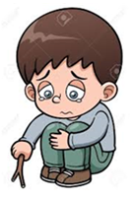

MOST IMPORTANTLY:-

If you are being bullied:

**MAKE SOME NOISE**