Mathematics Policy

St. Joseph’s Catholic Primary School, a Voluntary Academy

*“Trusting in God, Creating Tomorrow, Helping Today.”*

Introduction

_______________________________________________________________________

This policy has been developed in order to ensure that the teaching of Mathematics contributes to the fulfilment of the school’s mission.

As a school, we firmly believe that outstanding Mathematics today will enable our pupils to take their place in the world, creating a successful tomorrow.

The following school policies should be read in conjunction with this one:

* Calculation Policy
* Teaching and Learning Policy
* Curriculum Policy
* Assessment Policy
* Marking Policy
* Special Needs Policy
* Equal Opportunities Policy
* Homework Policy

Rationale

_______________________________________________________________________

Mathematics equips pupils with the uniquely powerful set of tools to understand and change the world. These tools include the ability to complete calculations with fluency; use their knowledge of fluency to reason logically, and apply their knowledge and understanding to problem solving skills, fully able to think in abstract ways. Mathematics is integral to all aspects of life and with this in mind, we endeavour to ensure that children develop a positive and enthusiastic attitude towards mathematics that will stay with them.

The National Curriculum 2014 for mathematics describes in detail what pupils must learn in each year group. Combined with the St. Joseph’s RC Primary School Calculation Policy, this ensures continuity and progression and high expectations for attainment in Mathematics.

It is vital that a positive attitude towards mathematics is encouraged amongst all of our pupils in order to foster confidence and achievement in a skill that is essential in our society. At St. Joseph’s, we use the National Curriculum 2014 for Mathematics as the basis of our mathematics programme. We are committed to ensuring that all pupils achieve mastery in the key concepts of mathematics, appropriate for their age group, in order that they make genuine progress and avoid gaps in their understanding that provide barriers to learning as they move through education.

Assessment for Learning, an emphasis on fluency, reasoning, problem solving and the development of mathematical thinking, and a rigorous approach to the development of teacher subject knowledge are therefore essential components of the St. Joseph’s RC Primary School approach to this subject.

Purpose

_______________________________________________________________________

*“...teachers’ knowledge of mathematics for teaching must be like an experienced taxi driver’s knowledge of a city, whereby one can get to significant places in a wide variety of ways, flexibly and adaptively.” (Ma, 1999, p. 123)*

*“Mathematics is a creative and highly inter-connected discipline that has been developed over centuries, providing the solution to some of history’s most intriguing problems. It is essential to everyday life, critical to science, technology and engineering, and necessary for financial literacy and most forms of employment. A high-quality mathematics education therefore provides a foundation for understanding the world, the ability to reason mathematically, an appreciation of the beauty and power of mathematics, and a sense of enjoyment and curiosity about the subject.”*

*(The National Curriculum in England framework document, 2014)*

Intent

_______________________________________________________________________

The intent of the St. Joseph’s Mathematics curriculum is to ensure that all children are well prepared for the next stage of their education and for futures post-18. We aim to provide an ambitious and engaging Mathematics curriculum along with high quality teaching to produce individuals who are numerate, creative, independent, inquisitive, enquiring and confident. It is our intent to provide a stimulating environment and adequate resources so that pupils can develop their mathematical skills to the full. Our ambition is for all children not to simply *do* Maths, but to fully *understand* Maths enabling them to make substantial and sustained progress as they journey through St. Joseph’s, working within their age related expectations, or wherever possible, at greater depth.

The intent for all staff at St. Joseph’s is for all of our children to be strong mathematicians because they:

* can recall and apply their knowledge confidently and efficiently;
* are secure in using written methods for which they have a clear understanding;
* have a strong conceptual understanding of maths; its structures and its relationships;
* are able to use and apply their knowledge and skills to solve challenging reasoning and problem solving tasks.

The above aims will be met because children will:

* have a well-developed sense of the size of a number and where it fits into the number system;
* know by heart number facts such as number bonds, multiplication tables (up to 12x12), doubles and halves;
* use what they know by heart to support mental calculation;
* calculate accurately and efficiently, both mentally and in writing, drawing on a range of calculation strategies;
* make sense of number problems, including ’real life’ problems and identify the operations needed to solve them; explain their methods and reasoning by using correct mathematical terms;
* judge whether their answers are reasonable and have strategies for checking them where necessary;
* suggest suitable units for measuring and make sensible estimates of measurements;
* explain and make predictions from the numbers in graphs, diagrams, charts and tables;
* develop spatial awareness and an understanding of the properties of 2D and 3D shapes.

As a school, we use the White Rose Scheme of Learning. The following Long Term Plans provide an overview of the Maths Curriculum for Reception to Year Six:

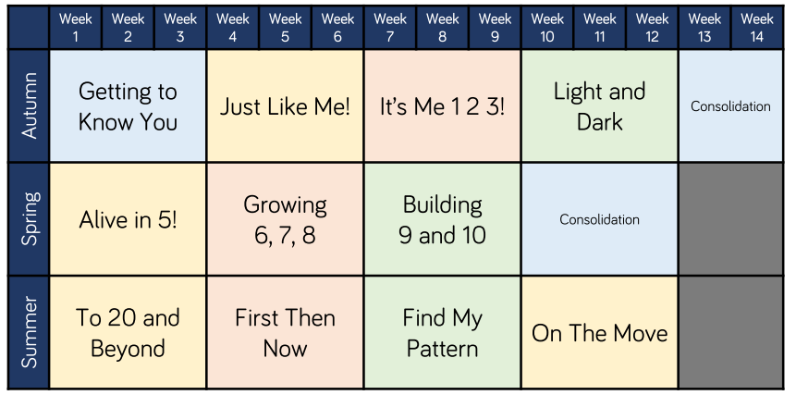Reception

Year 1

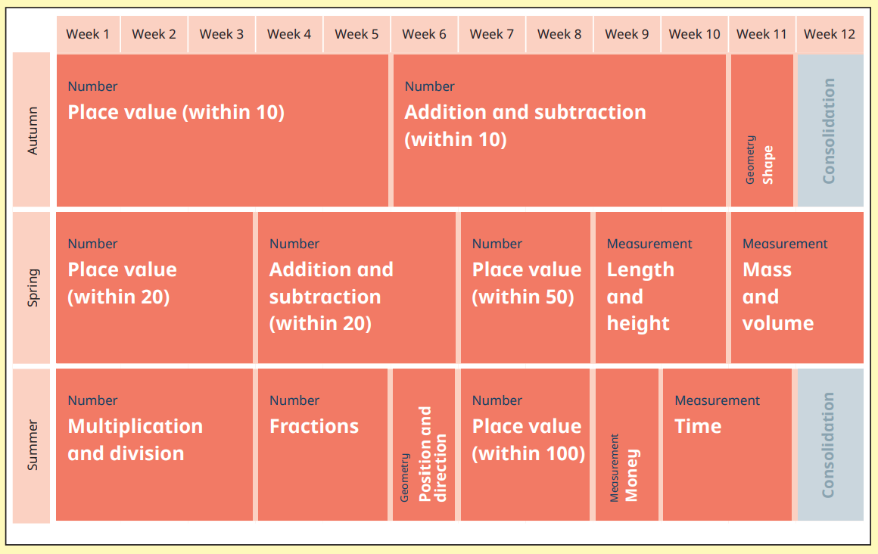

Year 2

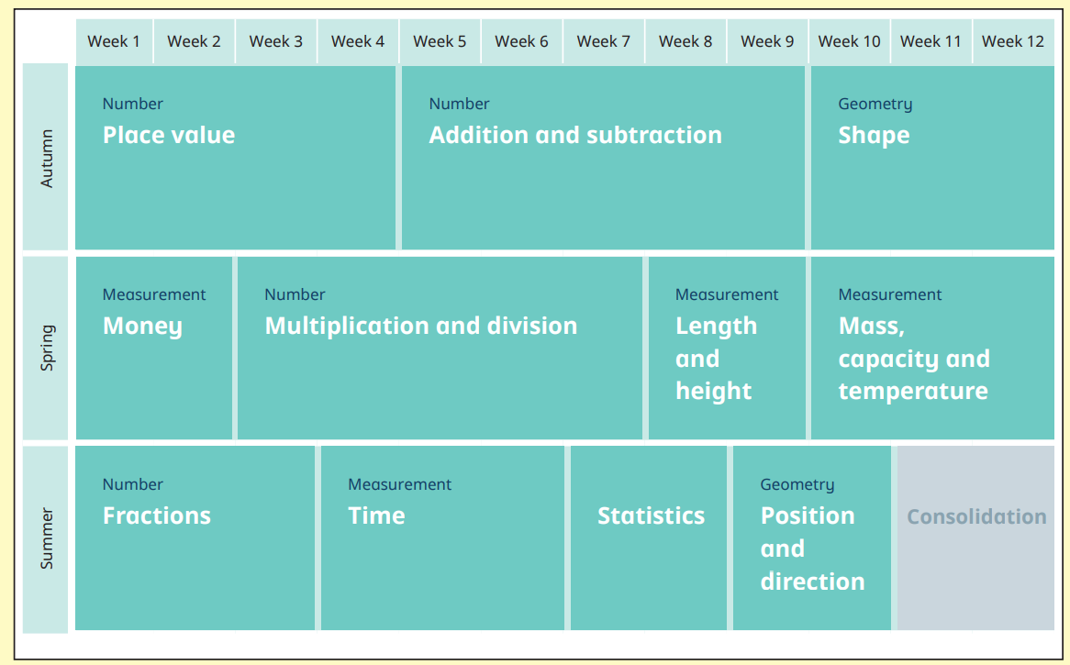

Year 3

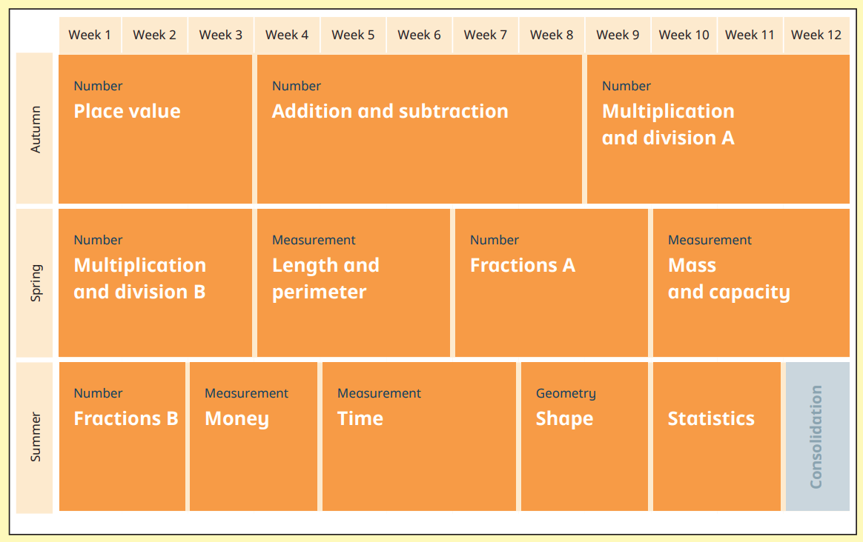

Year 4

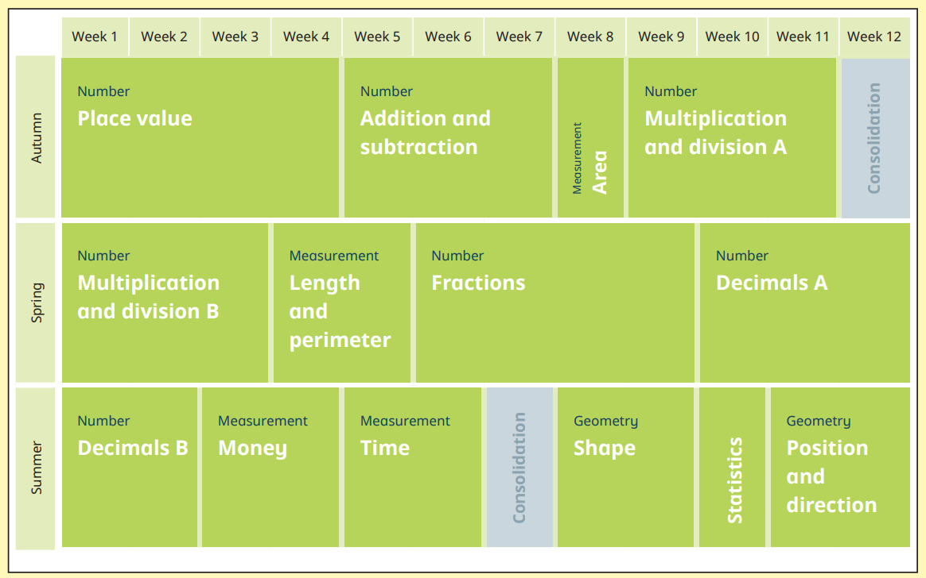

Year 5

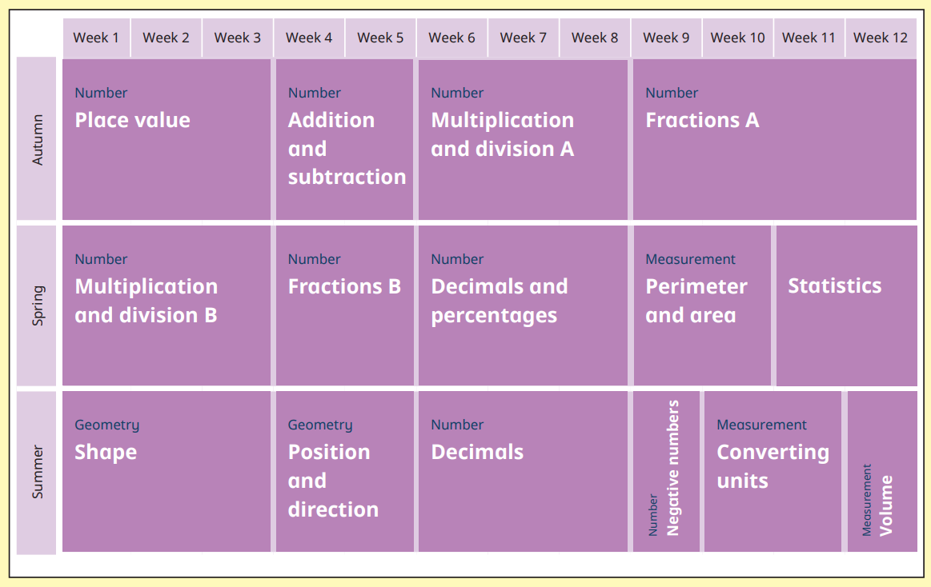

Year 6

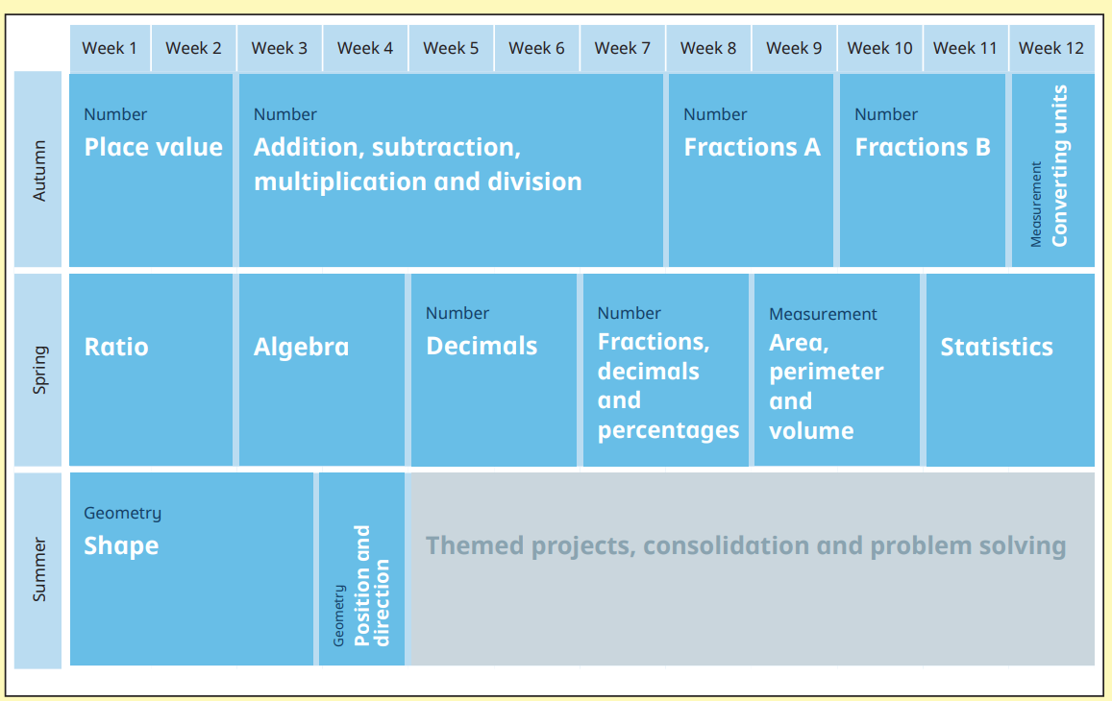

Please note that the above overview dictates the order of teaching. Staff aim to keep within the suggested weeks but, as a school, we have made the decision that learning should not be moved on too quickly, particularly if concepts have not been embedded; therefore, teachers may not be fully ‘on track’ with the guidelines above. Further to this, staff are encouraged to maximise opportunities for cross-curricular links to be made. This is to ensure learning is transferred across subjects but also to provide children with ‘real’ experiences. Therefore, Statistics, for example, will be delivered within the school’s Science curriculum and not necessarily within the Maths curriculum. The knowledge has been carefully mapped out by White Rose and this progression can be seen in each year group’s Curriculum Intent Document.

Implementation

_______________________________________________________________________

The school works to the expectations set out in the framework document for the National Curriculum in England, 2014 for Years 1 to 6 and the Early Years Foundation Stage Curriculum, 2012. Each year group follows the White Rose scheme of work, which is tailored to meet the individual needs of each cohort and to fulfil our intent for the children by the time they leave us.

Pre-Learning tasks are used at the beginning of a new block of learning. Teachers use these expertly to ensure the immediate next steps for learners are planned for. This ensures that teaching matches all pupils’ needs. Within a block of work, marking always informs planning for the next day ensuring that pupils’ needs are always planned for.

At the end of a block, Post-Learning tasks are used to ensure new knowledge and understanding has been retained and can be applied independently. To further support this, St. Joseph’s provides pupils with a weekly Friday Maths Challenge. This check will provide teachers with essential assessment information to ensure prior learning is embedded. Where learning has not been embedded, these are re-visited in the follow week’s Maths lessons.

The school’s Maths Curriculum is implemented with a triple emphasis on Fluency, Reasoning and Problem Solving.

Fluency

Our Maths Curriculum places a strong emphasis on Fluency where we ensure children have a secure understanding of place value and key number facts. We firmly believe that fluency in Maths works through intelligent practice (rather than just mechanical repetition).A key belief shared between all staff is that children must hold Mathematics in their hands before they can hold it in their heads. It is for this reason that a wide range of practical equipment is used in order to develop this conceptual understanding. These manipulatives include: Numicon; Base Ten apparatus, place value counters, counting sticks, bead strings, Cuisenaire Rods, number lines and the one hundred square. Manipulatives are used when introducing children to formal written methods to ensure they have a secure understanding of these. Once a child has grasped a concept, they are exposed to varied fluency activities which develop their understanding.

Reasoning

Where fluency is sufficiently developed and embedded, all pupils are provided with opportunities to deepen their learning through challenging Reasoning tasks. These tasks develop the children’s ability to conjecture, generalise and justify. Pupils will demonstrate clear and succinct reasoning using the terms ‘because’ (from Year 1 to Year 6) and ‘therefore’ (from Year 4 to Year 6).

Problem Solving

Finally, to enable pupils to master each unit of Mathematics, the children are encouraged and shown how to apply their knowledge and skills to rich mathematical Problem Solving tasks. These tasks are open-ended and challenging in their design and are carefully develop to build grit, perseverance and resilience. As well as this, pupils are taught to use systematic ways of working and, at the end of a task, are always encouraged to evaluate the approach taken.

Throughout all stages, children play with numbers, measures, shapes and patterns to develop numerical awareness and explore the idea of ‘proof.’ We promote mathematical games that involve point scoring and personal bests (both electronic, and ‘hands on’) as we know that if managed properly this is highly motivating.

*See also our Calculation Policy.*

What does a typical Maths lesson look like at St. Joseph’s Primary School?

_______________________________________________________________________

All teachers use the same planning format as we strongly believe in consistency. Lessons always begin with a counting starter. Here, children will practise and develop their knowledge of place value, counting and knowledge of key number facts. Afterwards, a Mental/Oral starter is used to recap on prior learning; this takes the form of the White Rose resource called ‘Flashback 4’. As a school, we have renamed this as our Knowing and Remembering More starter in line with other subjects. Children are given 4 questions which recap on prior learning and complete these with the staff going through the answers to support retrieval. This ensures that Mathematical concepts are not forgotten and practised regularly.

The main body of the lesson is then taught. However, not all groups will receive the same teaching because we operate a ‘fluid grouping’ system. This means pupils do not always work in the same group; instead, they move around the groups fluidly and work where their next step in learning will be met. Therefore, precise teacher input is given to each group rather than to the whole class. Within a block of work, teachers plan for deep coverage and mastery of the school’s curriculum. A unit typically develops Fluency initially, unless this is already secure for pupils. Opportunities to solve Reasoning and Problem Solving tasks are then provided once fluency has been sufficiently developed. Teachers always strive to ensure that different learning styles are catered for: visual, auditory and kinaesthetic. Teachers integrate the use of formative assessment strategies such as effective questioning, clear learning objectives, the use of success criteria (referred to in lessons as ‘Steps to Success’), and effective feedback and response, either verbally or in marking.

Each lesson finishes with a Plenary. This will involve work with the whole class, or within groups, to address misconceptions, identify progress, summarise key facts and ideas, or to make links to other work and to discuss next steps.

The teaching of arithmetic always follows the St. Joseph’s Calculation Policy, which gives an overview of the development of addition, subtraction, multiplication and division from Reception to Year 6. Teachers are expected to use this detailed information on progression through each strand and follow the guidance of using practical resources and models to develop understanding at each stage.

As discussed early, pupils complete a Friday Maths Challenge each week, which ensures prior learning has been retained. Here, questions are provided based on:

* three key areas of Maths in Key Stage 1: Place Value, Calculation and Shape, Space and Measure;
* four key areas of Maths in Key Stage 2: Place Value; Calculation; Fractions, Decimals and Percentages; and Space, Shape and Measure.

If pupils are unable to answer a certain question, or if it is clear that a previously taught concept has not been embedded, teachers will ensure these gaps are filled during the mental/oral starter in the following week’s lessons.

Weekly homework supports the daily Maths lesson as it is always linked to the topic being taught in school. Teachers use homework to assess each child’s understanding within that unit of work.

*See also our Calculation Policy and Homework Policy.*

Provision

_______________________________________________________________________

Pupils are provided with a variety of opportunities to develop and extend their Mathematical skills, including:

• Group work

• Paired work

• Whole class teaching

• Individual work

Pupils engage in:

• the development of mental strategies

• written methods

• practical work

• investigational work

• problem solving

• mathematical discussion

• consolidation of basic skills and number facts

• maths games and puzzles

Mathematics contributes to many subjects and it is important the children are given opportunities to apply and use Mathematics in real contexts. It is important that time is found in other subjects for pupils to develop their Mathematical skills, e.g. there should be regular, carefully planned opportunities for measuring in science and technology, for the consideration of properties of shape and geometric patterns in technology and art, and for the collection and presentation of data in history and geography. We endeavour at all times to set work that is challenging, motivating and encourages the pupils to think about how they learn and to talk about what they have been learning. Additional enrichment opportunities are provided for pupils to further develop mathematical thinking e.g. through cooking, music, and maths investigations and games.

To provide adequate time for developing mathematics, maths is taught daily and discretely. Maths lessons may vary in length but will usually last for about 45 minutes in Key Stage 1 and 60 minutes in Key Stage 2.

Inclusion

_______________________________________________________________________

The following principles inform and guide our policy and practise:

* meeting the diverse and complex needs of each and every individual is embedded in

everything that we do as a whole staff;

* it is the responsibility of the school to enable the child to access and make progress through the curriculum;
* equal opportunities is not the same as equal provision.

Above all, we celebrate and affirm the diversity in our school, our community, our society and our world and commit ourselves to enabling all our pupils to participate constructively as they grow.

For every child to be able to participate in the daily Mathematics lesson, we must know each of them as individuals. For children with SEND, teaching must be closely linked to their pupil passport targets. What is good provision for a child with SEND is good for all children i.e. an abundance of activities that allow children to learn visually, through speaking and listening and kinaesthetically.

We respond to children’s diverse learning needs by:

* creating effective learning environments;
* securing their motivation and concentration;
* providing equality of opportunity through a range of teaching approaches and modifying

these for individual needs;

* using appropriate assessments
* setting targets for learning;
* ensuring that every child make at least consistently strong progress because their learning is differentiated and precisely matched to their learning needs.

*See also our Inclusion policy.*

Resources

_______________________________________________________________________

At St. Joseph’s, we know that children become fluent in mathematics when they have lots of ‘hands on’ experiences. Therefore, children and staff draw on a wide range of practical resources in order to develop the conceptual understanding of maths - its structures and its relationships. This then helps children move smoothly to abstract representations and recorded methods. Good use of resources also helps make the learning more interesting. In every class from Year 1 to Year 6, children have a ‘Toolbox’ on their table. This allows them to choose and use a resource independently if they feel it would support them in carrying out a task. Further resources relating to key whole school topics, for example ‘Fractions’ are kept in the Mathematics Resource Centre. Teacher’s reference books and research documents are kept in the same area.

Information and Communication Technology

_______________________________________________________________________

ICT is used in various ways to support teaching and motivate children’s learning. Each classroom has an interactive whiteboard and some classrooms have access to a scanner, visualiser and Apple TV. All teachers are provided with a laptop to support their planning and provision, and are encouraged to use ICT to enhance teaching and learning in mathematics where appropriate. The school is equipped with two laptop trolleys (each with 15 laptops) and 40 Ipads. The school subscribes to ‘MyMaths’ and ‘Timestables Rockstars’ to facilitate further practise of key skills online and at home.

The Role of Teaching Assistants

_______________________________________________________________________

Teaching Assistants are actively involved in teaching small groups within lessons and in providing intervention sessions. They support all groups in each lesson, enabling the teacher to also work with all groups on a daily basis. They offer sensitive support and modify tasks, materials and teaching resources as required.

Our skilled Teaching Assistants demonstrate initiative in using practical resources to support learning and help pupils overcome difficulties, for example by using strings of counting beads to aid early multiplication. They are careful not to over-direct pupils’ learning.

Teaching Assistants at St. Joseph’s are able to spot misconceptions and gaps in learning; they take responsibility for assessing pupils in any groups with which they work. They then help to identify the next steps and plan subsequent activities with the class teachers. Our TAs regularly participate in reviewing pupils’ progress and are particularly effective in identifying and supporting personal problems that presented barriers to learning.

Where a learning intention has not been met, TAs deliver an IMPACT session which is held immediately after the lesson. In these sessions, TAs are highly skilful at recognising the misconception during the lesson and overcome this, through questioning, modelling and/or further explaining.

Impact

_______________________________________________________________________

The impact of a block of work can be measured from Pre-Learning to Post-Learning tasks. Furthermore, Friday Maths Challenge is used to measure a child’s knowledge and understanding of place value, calculation, fractions, decimals and percentages and space, shape and measure.

IMPACT sessions are provided for children where learning has not been understood this *(see also our Marking Policy)*. Once IMPACT has been received, teachers should enable pupils to attempt the same task the follow day to ensure learning has been understood.

At the end of each term, children sit assessment tests, based on that term’s learning. These tests follow the same format as the end of Key Stage 1 & 2 SATs papers consisting of an Arithmetic paper and often two Reasoning papers. The Reasoning Papers are designed to assess whether students can apply the maths they have learnt and understand what they are doing. Assessment information is then obtained from the tests and is used to dictate provision and set targets for the next half term. These assessment tests also inform teacher’s assessments of pupils’ attainment and progress and are analysed by Miss Queenan, the Mathematics Subject Leader and used to inform target-setting.

In Year 2 and Year 6, Standardised Assessment Tests (SATs) are completed by children. These tests are national and the results are used to measure a school’s performance in Mathematics compared with schools locally and nationally. Children are expected to be competent in arithmetic and must be able to reason. In Key Stage 1, pupils complete two Mathematics test papers: Paper 1: Arithmetic and Paper 2: Reasoning. In Key Stage 2, pupils complete three Mathematics test papers: Paper 1: Arithmetic, Paper 2 & 3, Reasoning. The 2022 Mathematics KS1 SATs papers can be found [here](https://www.gov.uk/government/publications/key-stage-1-tests-2022-mathematics-test-materials); the KS2 SATs papers can be found [here](https://www.gov.uk/government/publications/key-stage-2-tests-2022-mathematics-test-materials).

The Role of the Subject Leader

_______________________________________________________________________

The subject leader for Mathematics is Miss Queenan. The subject leader:

* ensures teachers understand the requirements of the National Curriculum and supports individuals with lesson planning;
* leads by example by setting high standards in their own teaching;
* prepares, organises and leads Continuing Professional Development and joint professional development – especially lesson study, lesson observations and monitoring activities, with the support of the Headteacher;
* attends CPD provided by the Our Lady of Lourdes Multi-Academy Trust, or Derbyshire County Council and other providers;
* keeps parents informed about Mathematics issues, which may include holding information and training evenings;
* discusses the progress of pupils in Mathematics and any identified staff training needs regularly with the Executive Headteacher and governors;
* monitors and evaluates mathematics provision in the school by conducting regular work scrutiny, learning walks, pupil interviews and anaylsing data.

Continuing Professional Development (CDP)

_______________________________________________________________________

Leaders and Governors at St. Joseph’s believe that outstanding teaching is underpinned by providing staff with regular professional development opportunities to ensure their expertise and subject knowledge is always developed and kept contemporary. Regular professional development is always identified by the Senior Leadership Team and Maths subject leader as part of the subject’s development plan. Clear and precise professional development, from a range of sources, will ensure:

* the mathematics curriculum is delivered thoroughly and consistently;
* staff subject knowledge is enhanced and up-to-date;
* teachers are confident with using a range of practical and electronic resources to support the teaching and learning of abstract concepts.
* Assessment for Learning is consistently strong and is used accurately to identify each child’s next step in learning.
* teachers are knowledgeable and confident when choosing an intervention programme for pupils who are working below age related expectations or are making less than consistently strong progress.

*See also our Teaching and Learning policy.*

Last reviewed: November 2022

Date of next review: November 2024

Signed: E Queenan

(Mathematics Subject Leader)