[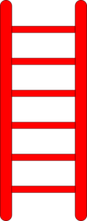](http://www.clker.com/cliparts/H/3/P/G/3/G/red-ladder-md.png)

[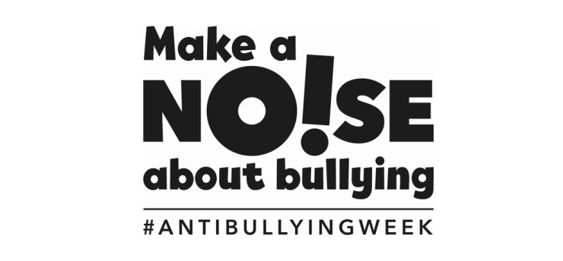](http://www.google.co.uk/url?sa=i&rct=j&q=&esrc=s&source=images&cd=&cad=rja&uact=8&ved=0CAcQjRxqFQoTCPG0rLmfmMkCFYcZDwodm3UFOg&url=http://www.ncb.org.uk/news/make-a-noise-about-bullying&bvm=bv.107467506,d.ZWU&psig=AFQjCNFJtueXxtgqpF-WtddrD-xmaL2Jbw&ust=1447876725268559)[](http://www.google.co.uk/url?sa=i&rct=j&q=&esrc=s&source=images&cd=&cad=rja&uact=8&ved=0CAcQjRxqFQoTCPXpjOSfmMkCFUF0DwodCx8DLg&url=http://allsaints.notts.sch.uk/trust/main.asp?menu=contact.asp&bvm=bv.107467506,d.ZWU&psig=AFQjCNFQJ6uw9ycckAcc4yakKFjMF9a8Ew&ust=1447876855719871)

1. **IGNORE what is being said or done to you.**
2. **TALK NICE to show you are not a threat always saying kind words.**
3. **TALK FIRM and make it clear you do not like what they are saying or doing.**
4. **WALK AWAY to stop it escalating and go to a safe place with other children.**
5. **TELL A TEACHER about the situation and how it’s made you feel.**