[](http://www.publicdomainpictures.net/view-image.php?image=85632&picture=border-star&large=1)[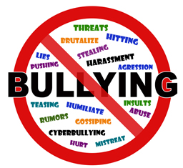](https://www.google.co.uk/url?sa=i&rct=j&q=&esrc=s&source=images&cd=&cad=rja&uact=8&ved=0CAcQjRxqFQoTCLjTjpiamMkCFUjZDgodkagONw&url=https://www.adcq.qld.gov.au/resources/brochures-and-guides/fact-sheets/bullying-factsheet&psig=AFQjCNEUz8C2UIPxoNM-8D45vbplthHdNQ&ust=1447875358938597)

**We pledge to block bullying in school and we**:

* Agree not to bully others both inside and outside of school.
* Agree to include others who have been left out.
* Agree to help other children who are being bullied by speaking out and getting help.

[](https://www.google.co.uk/url?sa=i&rct=j&q=&esrc=s&source=images&cd=&cad=rja&uact=8&ved=0CAcQjRxqFQoTCLjTjpiamMkCFUjZDgodkagONw&url=https://www.adcq.qld.gov.au/resources/brochures-and-guides/fact-sheets/bullying-factsheet&psig=AFQjCNEUz8C2UIPxoNM-8D45vbplthHdNQ&ust=1447875358938597)